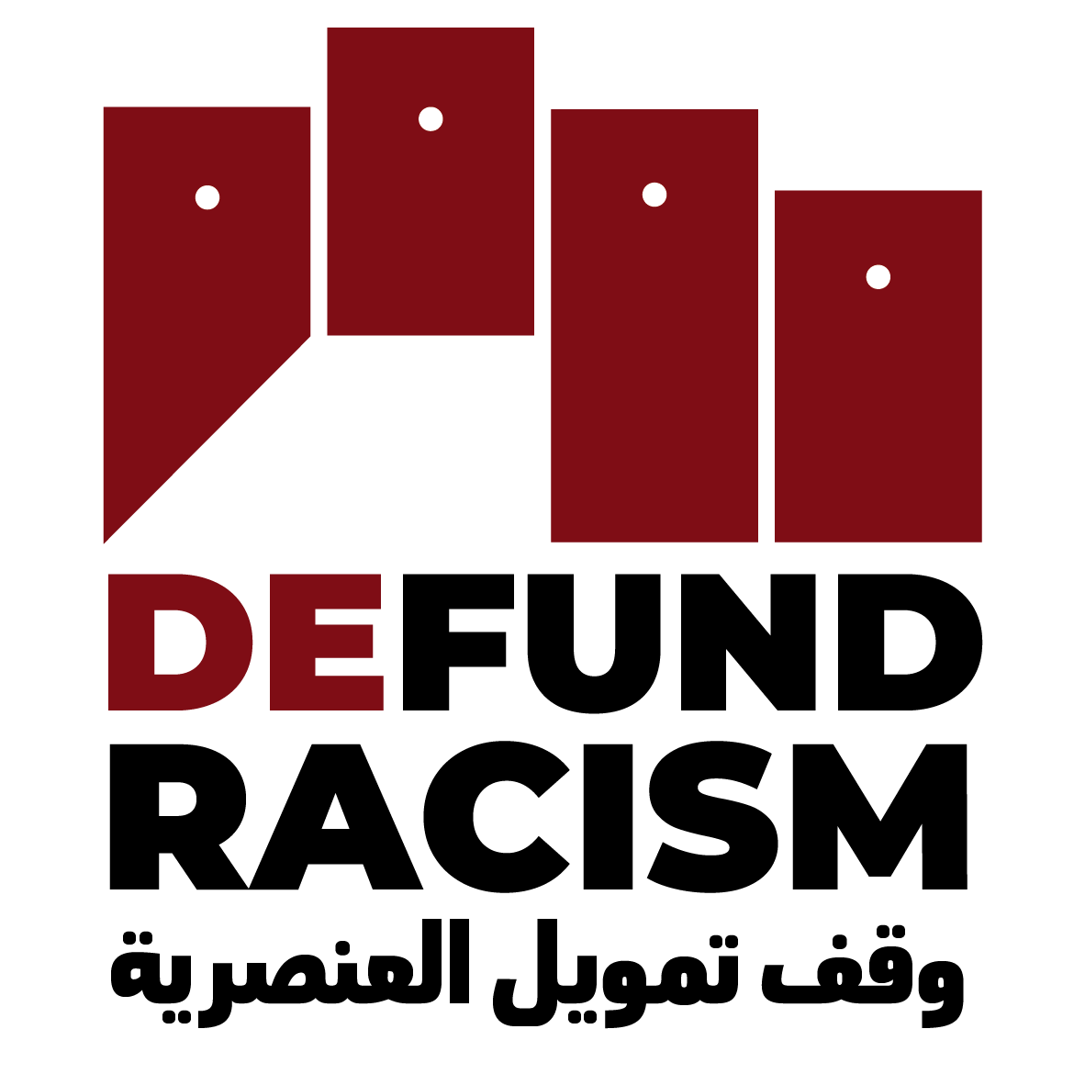
#DefundRacism - Posting Plan I

The campaign #DefundRacism aims to stop the transfer of charitable money to racist and illegal settler-organizations in Historic Palestine. We call for an investigation of the settler organizations` charity status by the Attorney General in New York State, where these organizations, or their fiscal sponsors are registered. This would end the flow of charitable money to settler-colonialism. In this Posting Plan, you find everything you need to support the campaign on Social Media.
We have planned three posts per week. The links to the graphics are in the right column, and can be downloaded with the link next to it. And of course, in any post your organization does about the settler-organizations and current situation, you can simply add the link to the petition: defundracism.org & the Hashtag #DefundRacism

Date: | Facebook Text: | Arabic Text: | Twitter Text: | Insta-Text: | Photo English (Insta) | Photo English (FB/Twitter) | Photo Arabic
Week 1 | From Sheikh Jarrah and Silwan to Hebron and the Naqab, Israeli settler organizations work to demolish Palestinian homes and evict entire Palestinian communities. These settler organizations' actions are funded by charitable money from the US. Palestinian and international activists on the ground are calling on the people in the US to stop funding racism under the guise of "charitable works."  We call for the New York State Attorney General to investigate and revoke the charitable status of organizations funding settler-colonialism.  Join our campaign to #DefundRacism  defundracism.org | من الشيخ جراح وسلوان إلى الخليل والنقب، تعمل منظمات المستوطنين الإسرائيلية على هدم منازل الفلسطينيين وطرد مجتمعات فلسطينية بأكملها. يتم تمويل أعمال منظمات المستوطنين هذه من الأموال الخيرية من الولايات المتحدة. يدعو نشطاء فلسطينيون ودوليون على الأرض الناس في الولايات المتحدة إلى وقف تمويل العنصرية تحت ستار "الأعمال الخيرية".  وندعو المدعي العام لولاية نيويورك إلى التحقيق في الوضع الخيري للمنظمات التي تمول الاستعمار الاستيطاني وإلغاءه.  انضموا إلى حملتنا #DefundRacism  defundracism.org | The Israeli settler movement drives Israeli policy. It sets the agenda, develops the tactics to erase Palestinian communities. The organizations exploit US charitable laws to finance their system of apartheid. Join the Palestinian campaign to #DefundRacism defundracism.org | From Sheikh Jarrah and Silwan to Hebron and the Naqab, Israeli settler organizations work to demolish Palestinian homes and evict entire Palestinian communities. These settler organizations' actions are funded by charitable money from the US. Palestinian and international activists on the ground are calling on the people in the US to stop funding racism under the guise of "charitable works."  We call for the New York State Attorney General to investigate and revoke the charitable status of organizations funding settler-colonialism.  Join our campaign to #DefundRacism  defundracism.org | For Instagram, we have a series of photos:  Photo-6  Photo-5  Photo-4  Photo-3  Photo-2  Photo-1 | Link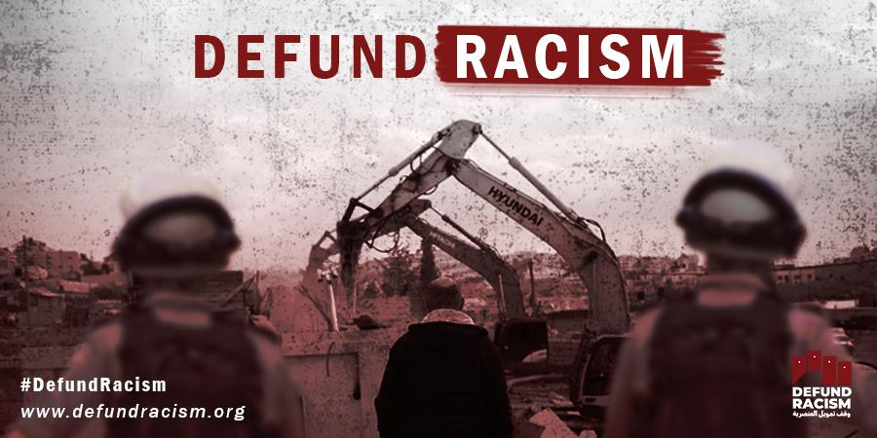 | For Instagram, we have a series of photos, FB & Twitter can simply use the first one:  Photo-6  Photo-5  Photo-4  Photo-3  Photo-2  Photo-1
Week 1 | Since 2009, Israel has destroyed more than 7,500 Palestinian structures, including homes. They have displaced more than 11,500 people to maintain a system of apartheid. It is not merely the Israeli government or military which is behind these violations of international law. Racist settler organizations, such as Ateret Cohanim, Regavim and Elad, push the government to destroy the homes of Palestinians - evicting their communities. US tax-deductible dollars fund this racist work. Through US-based fiscal sponsors and fundraisers, such as the Central Fund of Israel, American Friends of Ateret Cohanim, and many more, vast portions of money are funneled into the Israeli settler movement.  We believe that the demolition of homes is not charitable work. If you agree, join our call to #DefundRacism  defundracism.org  Photo: Reuters | ومنذ عام 2009، دمرت إسرائيل أكثر من 500 7 مبنى فلسطيني، بما في ذلك المنازل. وقد شردوا أكثر من 500 11 شخص للحفاظ على نظام الفصل العنصري. وليست الحكومة الإسرائيلية أو الجيش الإسرائيلي فقط هو الذي يقف وراء هذه الانتهاكات للقانون الدولي. وتدفع منظمات المستوطنين العنصريين، مثل عطيريت كوهانيم وريغافيم وإلعاد، الحكومة إلى تدمير منازل الفلسطينيين - وطرد مجتمعاتهم المحلية. وتمول الدولارات الأمريكية المعفاة من الضرائب هذا العمل العنصري. ومن خلال الرعاة الماليين وحملات جمع التبرعات التي تتخذ من الولايات المتحدة مقرا لها، مثل الصندوق المركزي لإسرائيل، وأصدقاء عطيريت كوهانيم الأميركيين، وغيرهم. الكم الأكبر من الأموال، يتم تحويلها إلى حركة المستوطنين الإسرائيليين.  ونعتقد أن هدم المنازل ليس عملا خيريا. إذا وافقت، انضم إلى دعوتنا إلى #DefundRacism  defundracism.org | Since 2009, Israel has destroyed more than 7,500 Palestinian structures, including homes. They have displaced more than 11,500 people to maintain a system of apartheid. Settler orgs exploit US charitable laws for indigenous erasure. Join the call to defundracism.org | Since 2009, Israel has destroyed more than 7,500 Palestinian structures, including homes. They have displaced more than 11,500 people to maintain a system of apartheid. It is not merely the Israeli government or military which is behind these violations of international law. Racist settler organizations, such as Ateret Cohanim, Regavim and Elad, push the government to destroy the homes of Palestinians - evicting their communities. US tax-deductible dollars fund this racist work. Through US-based fiscal sponsors and fundraisers, such as the Central Fund of Israel, American Friends of Ateret Cohanim, and many more, vast portions of money are funneled into the Israeli settler movement.  We believe that the demolition of homes is not charitable work. If you agree, join our call to #DefundRacism  defundracism.org  Photo: Reuters | Link | Link | Link
Week 1 | Palestinians in Silwan face imminent, large-scale home demolitions and ethnic cleansing. While information about the community is circulating widely, many still don’t know that US dollars directly fund this violence. The settler organization behind many demolitions in Silwan - Elad - receives charitable money through their American fundraiser, American Friends of Ir David. From 1999 to 2018, this organization has made $144,964,572 in gross receipts.  There is a winnable and straightforward way to stop the flow of charitable money into the settler movement. The New York State Attorney General, Letitia James, can decide to revoke the charitable status of this racist organization. Support Palestinians on the ground making the call to #DefundRacism:  defundracism.org  #SaveSilwan | ويواجه الفلسطينيون في سلوان عمليات هدم وشيكة واسعة النطاق للمنازل وتطهيرا عرقيا. وفي حين تنتشر المعلومات حول المجتمع على نطاق واسع، لا يزال الكثيرون لا يعرفون أن الدولارات الأمريكية تمول هذا العنف بشكل مباشر. منظمة المستوطنين وراء العديد من عمليات الهدم في سلوان - Elad - تتلقى الأموال الخيرية من خلال جمع التبرعات الأمريكية من أصدقاء ديفيد الأمريكية. وفي الفترة من عام 1999 إلى عام 2018، حققت هذه المنظمة إيرادات إجمالية قدرها 572 964 144 دولارا.  هناك طريقة يمكن كسبها ومباشرة لوقف تدفق الأموال الخيرية إلى حركة المستوطنين. ويمكن للمدعية العامة لولاية نيويورك، ليتيتيا جيمس، أن تقرر إلغاء الوضع الخيري لهذه المنظمة العنصرية. دعم الفلسطينيين على الأرض الذين يدعون إلى #DefundRacism:  defundracism.org  #SaveSilwan | Elad & Ateret Cohanim have secured millions of $$, exploiting the US charitable system to finance the wholesale displacement and erasure of indigenous communities in Silwan. The New Attorney General has the power to stop this! Join the Palestinian call to defundracism.org | Palestinians in Silwan face imminent, large-scale home demolitions and ethnic cleansing. While information about the community is circulating widely, many still don’t know that US dollars directly fund this violence. The settler organization behind many demolitions in Silwan - Elad - receives charitable money through their American fundraiser, American Friends of Ir David. From 1999 to 2018, this organization has made $144,964,572 in gross receipts.  There is a winnable and straightforward way to stop the flow of charitable money into the settler movement. The New York State Attorney General, Letitia James, can decide to revoke the charitable status of this racist organization. Support Palestinians on the ground making the call to #DefundRacism:  defundracism.org  #SaveSilwan | Link  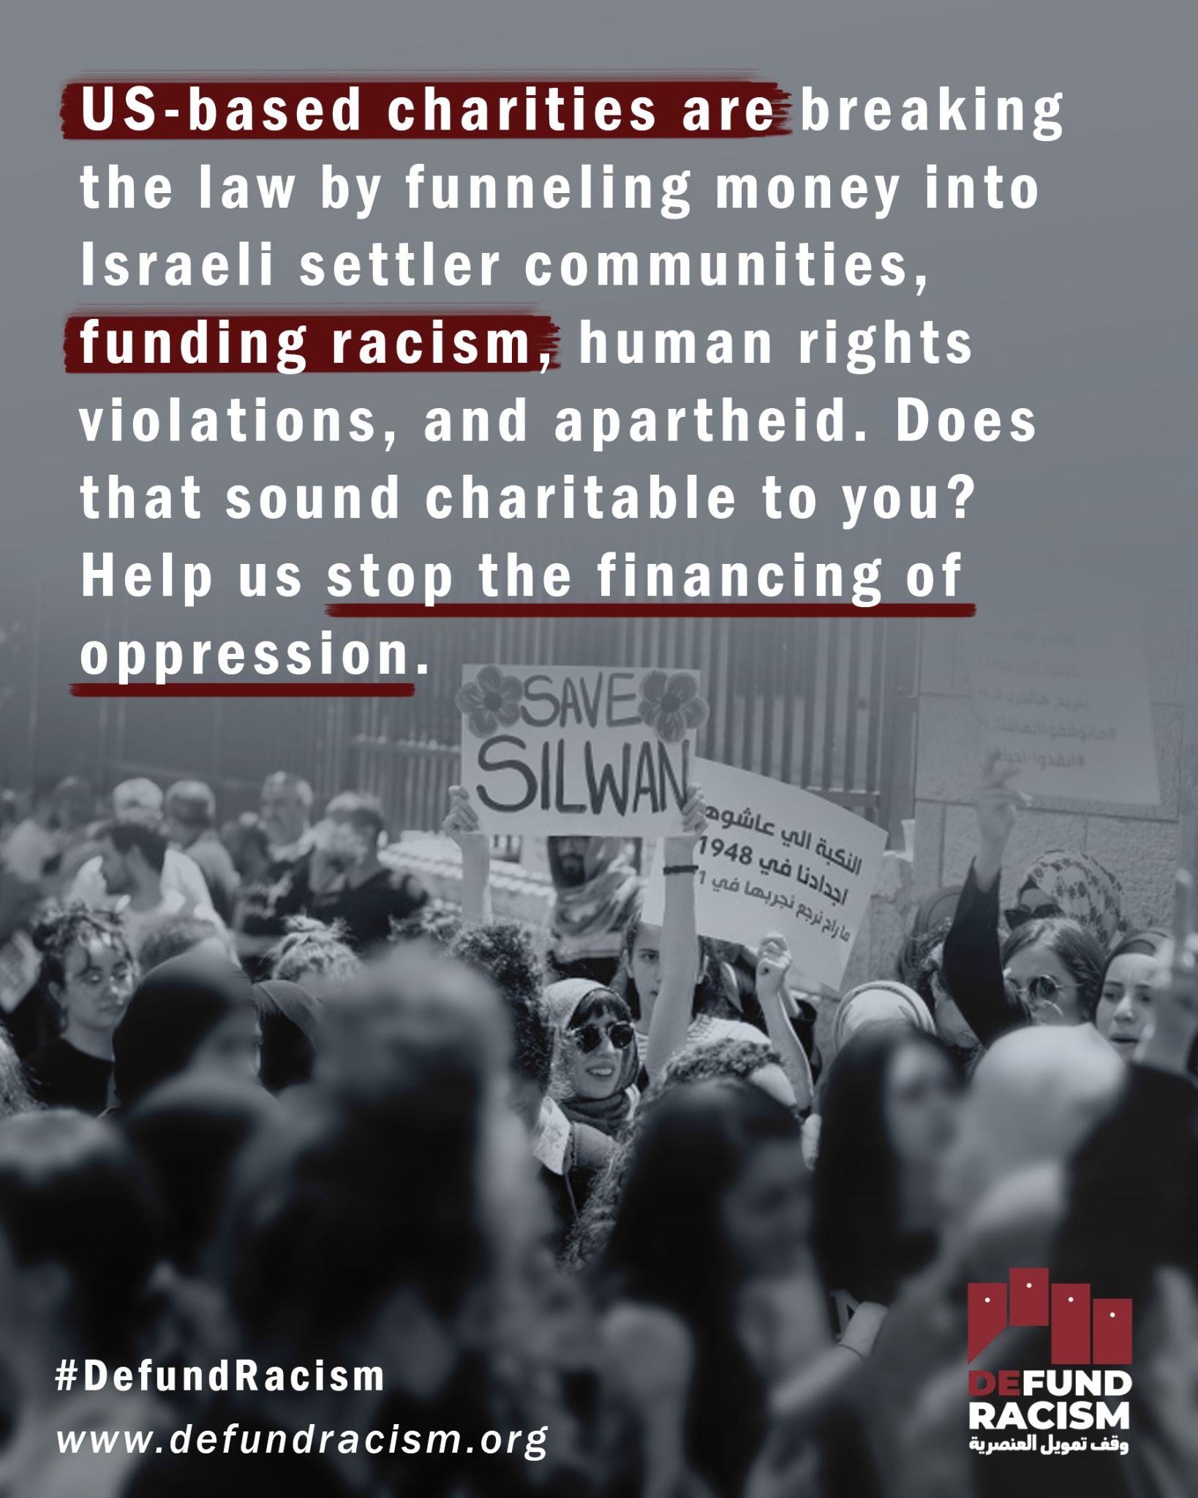 | Link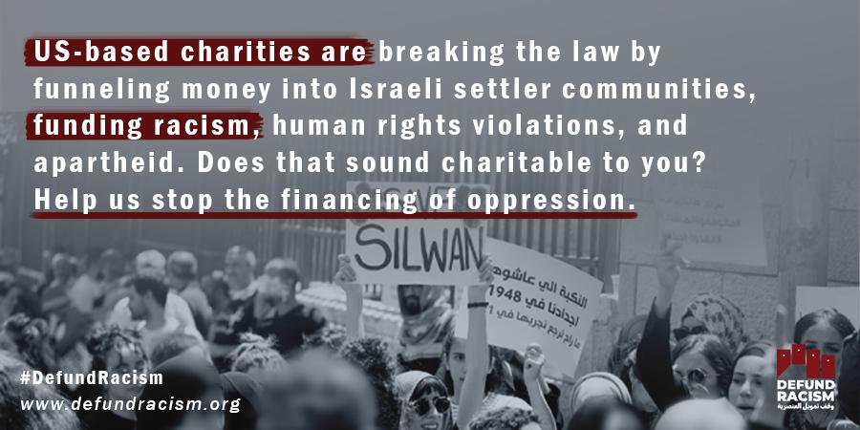 | Link  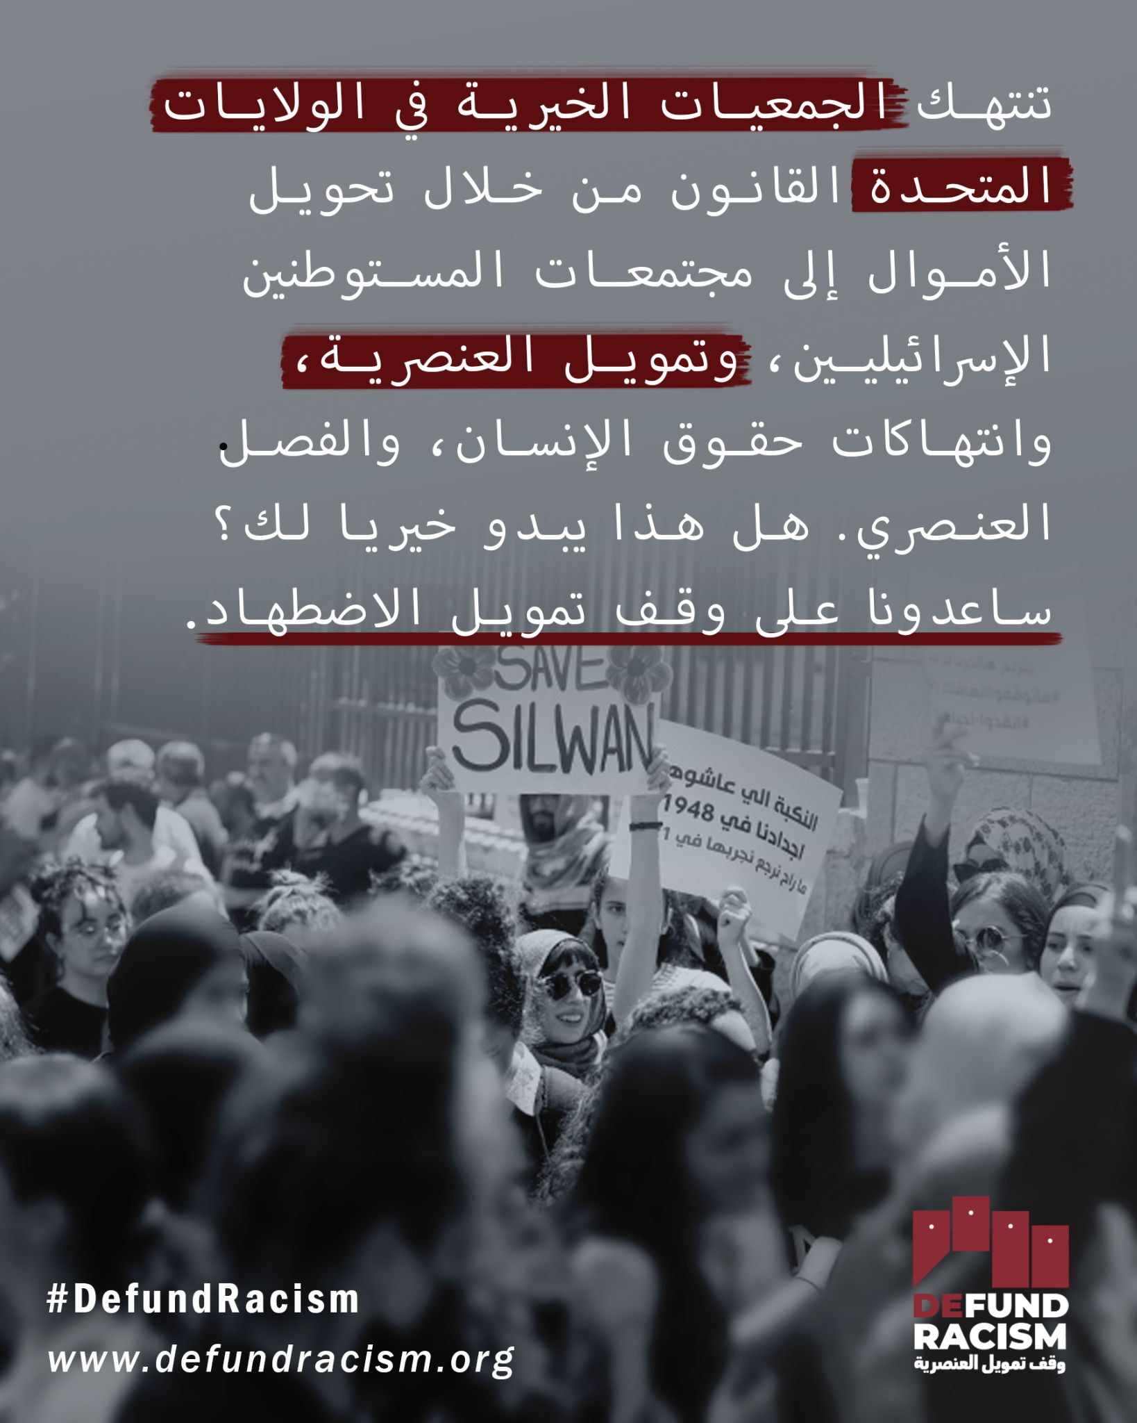
Week 2 | Strangled by Israeli settler organizations, from Sheikh Jarrah to Silwan to Hebron, Palestinian communities are calling on the international community to stop financing and granting impunity to settler organizations. Sign this petition here to #DefundRacism  defundracism.org  Photo: Christian Peacemaker Teams | تدعو المجتمعات الفلسطينية المجتمع الدولي، الذي خنقته منظمات المستوطنين الإسرائيليين، من الشيخ جراح إلى سلوان إلى الخليل، إلى وقف التمويل ومنع الإفلات من العقاب لمنظمات المستوطنين. وقع على هذه العريضة هنا #DefundRacism  defundracism.org | New York Attorney General Letitia James has the power to investigate and revoke the charitable licenses of the organizations financing Israel's system of apartheid: The Hebron Fund, Elad, the Israel Land Fund. Call on James now to #DefundRacism defundracism.org | Strangled by Israeli settler organizations, from Sheikh Jarrah to Silwan to Hebron, Palestinian communities are calling on the international community to stop financing and granting impunity to settler organizations. Sign this petition here to #DefundRacism  defundracism.org  Photo: Christian Peacemaker Teams | Link | Link | Link
Week 2 | The Hebron Fund, American Friends of Ateret Cohanim, American Friends of Ir David, the Central Fund of Israel, and many more, are US-based organizations that enjoy charitable status, meaning that all of the money they raise is tax-exempt. In practice, these organizations funnel these funds to illegal Israeli settlements, advancing a system of Israeli apartheid. The Israeli settlements on occupied lands, including East Jerusalem, are illegal under international law, meaning that these organizations actively violate international laws.  We don’t believe that this constitutes “charitable” work, or that US taxpayers are willing to front the bill for acts illegal under international law. Stand with us by signing the petition to strip these organizations of their charitable status. Call on New York Attorney General Letitia James to exercise her power and revoke the charitable status of organizations that execute programs of racism. #DefundRacism  defundracism.org | صندوق الخليل، والأصدقاء الأمريكيون لعطيريت كوهانيم، وأصدقاء ديفيد الأمريكيين، والصندوق المركزي لإسرائيل، وغيرها الكثير، هي منظمات مقرها الولايات المتحدة تتمتع بوضع خيري، مما يعني أن جميع الأموال التي تجمعها معفاة من الضرائب. ومن الناحية العملية، توجه هذه المنظمات هذه الأموال إلى المستوطنات الإسرائيلية غير القانونية، مما يعزز نظام الفصل العنصري الإسرائيلي. إن المستوطنات الإسرائيلية على الأراضي المحتلة، بما في ذلك القدس الشرقية، غير قانونية بموجب القانون الدولي، مما يعني أن هذه المنظمات تنتهك القوانين الدولية بشكل فعال.  لا نعتقد أن هذا يشكل عملا "خيريا"، أو أن دافعي الضرائب الأمريكيين على استعداد لمواجهة مشروع قانون الأعمال غير القانونية بموجب القانون الدولي. الوقوف معنا من خلال التوقيع على عريضة لتجريد هذه المنظمات من وضعها الخيري. دعوة المدعية العامة في نيويورك ليتيتيا جيمس إلى ممارسة سلطتها وإلغاء الوضع الخيري للمنظمات التي تنفذ برامج العنصرية. #DefundRacism  defundracism.org | New York Attorney General Letitia James can revoke the charitable licenses of Israeli settler organizations; unlike the IRS, she is an elected official who can be held accountable by a mass movement of people willing to vote her out. Now is the time to defundracism.org | The Hebron Fund, American Friends of Ateret Cohanim, American Friends of Ir David, the Central Fund of Israel, and many more, are US-based organizations that enjoy charitable status, meaning that all of the money they raise is tax-exempt. In practice, these organizations funnel these funds to illegal Israeli settlements, advancing a system of Israeli apartheid. The Israeli settlements on occupied lands, including East Jerusalem, are illegal under international law, meaning that these organizations actively violate international laws.  We don’t believe that this constitutes “charitable” work, or that US taxpayers are willing to front the bill for acts illegal under international law. Stand with us by signing the petition to strip these organizations of their charitable status. Call on New York Attorney General Letitia James to exercise her power and revoke the charitable status of organizations that execute programs of racism. #DefundRacism  defundracism.org | Link  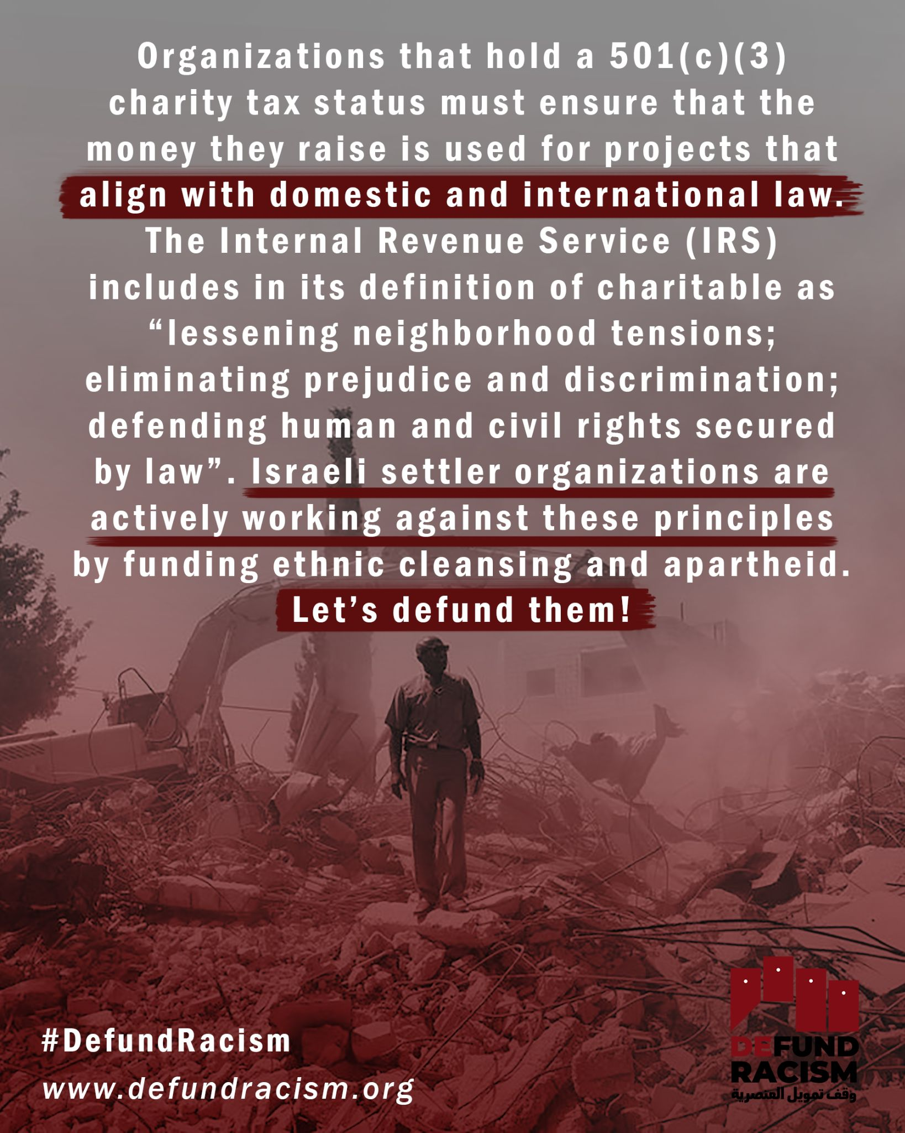 | Link  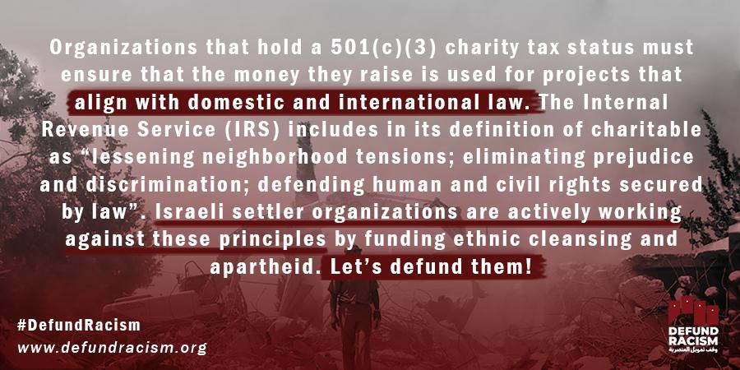 | Link  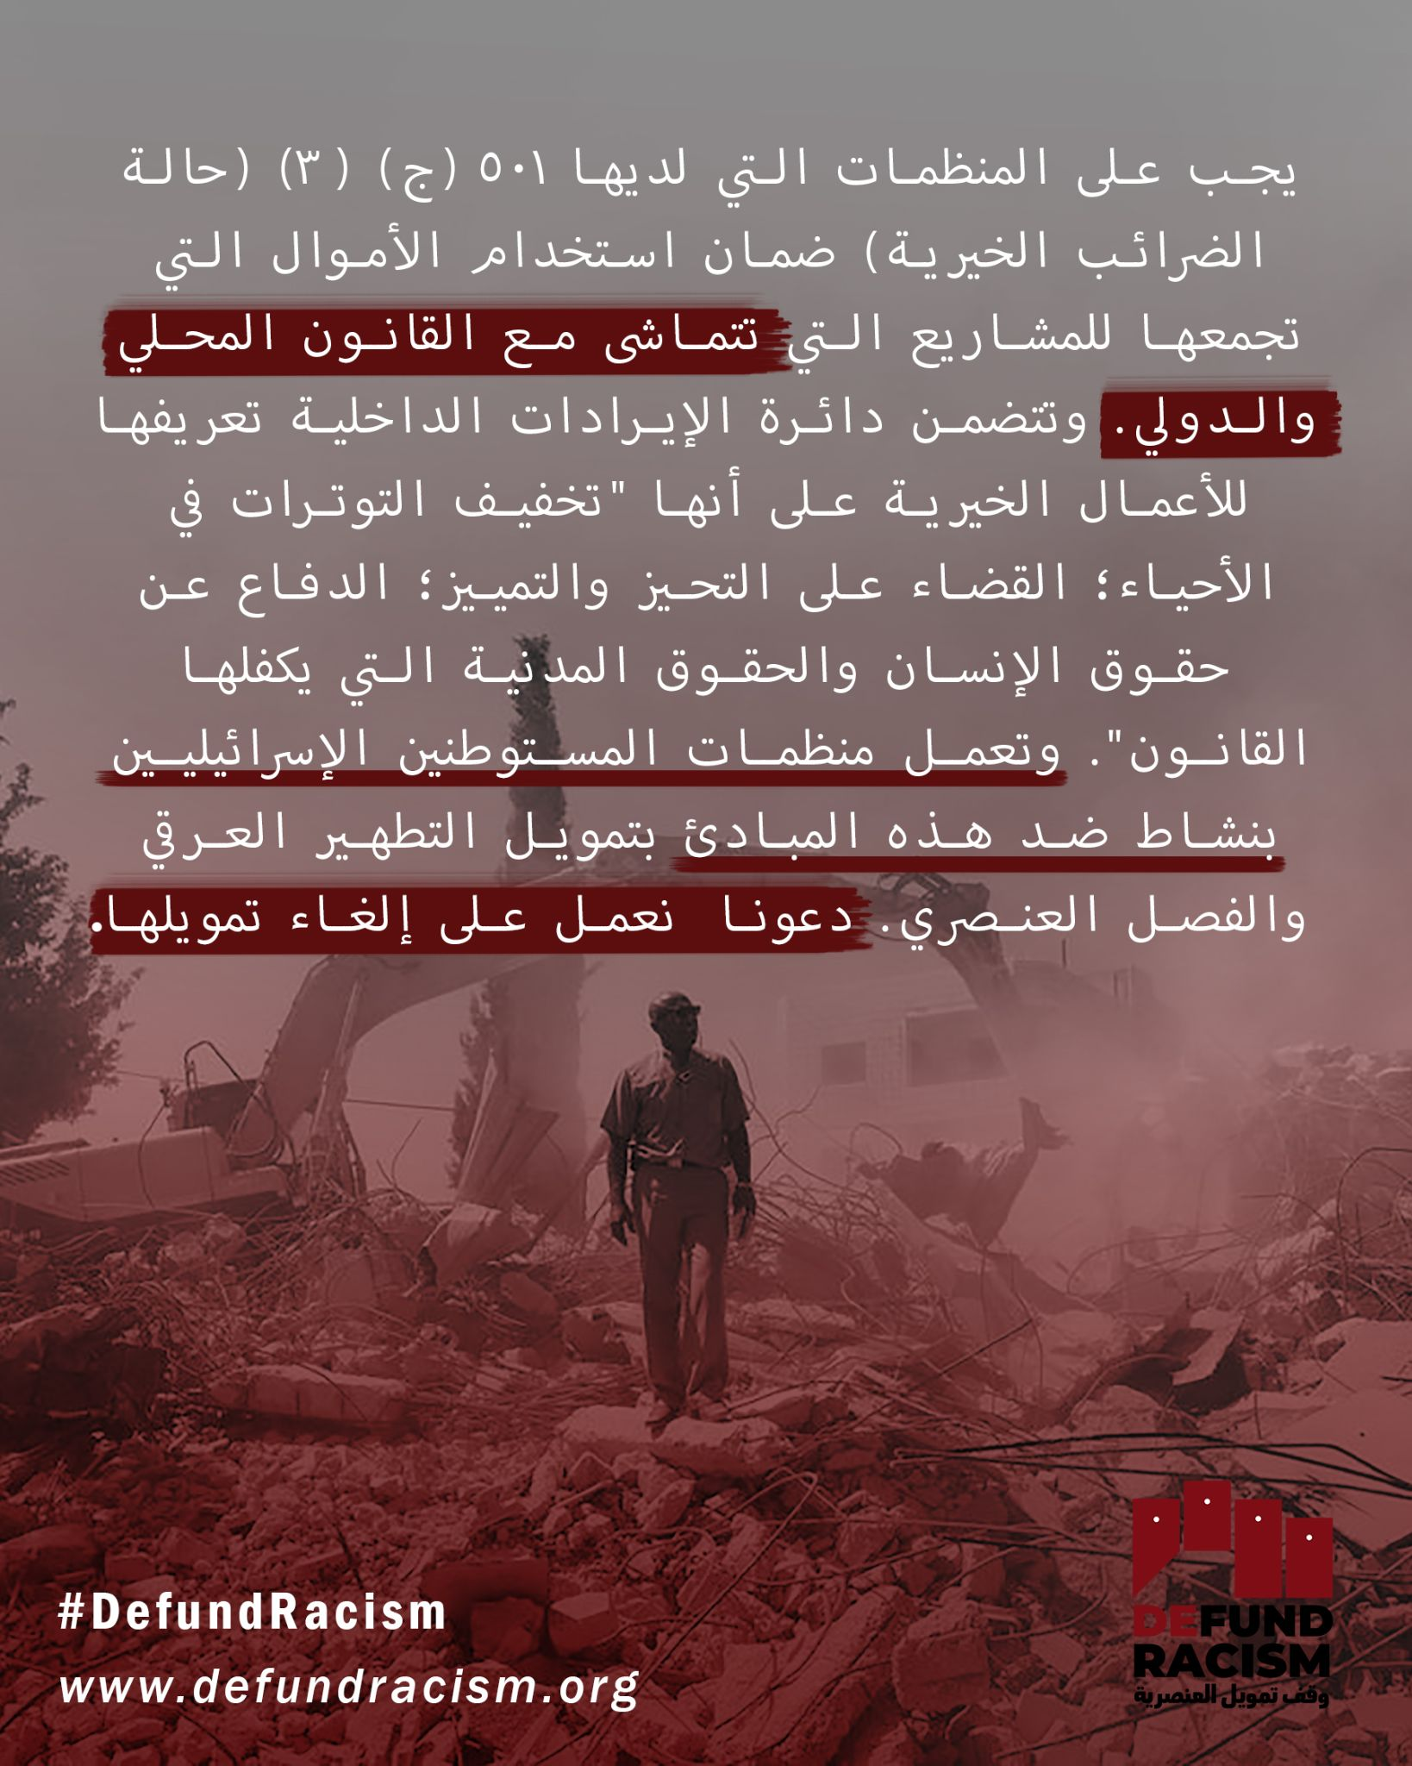
Week 2 | A series of laws and policies perpetuate Israel's program of settler-colonialism and the erasure of indigenous people. To stand in solidarity with Palestinians means working strategically to enact winnable and impactful campaigns. A coalition of Palestinian organizations is asking you to step into this space of solidarity, sign this petition to defund the racist settler organizations, and share it with your friends. These acts of solidarity are crucial to building a movement of support that can force New York Attorney General Letitia James to investigate and act in meaningful ways to stop the flow of money that essentially finances the oppression of Palestinians.  defundracism.org  #DefundRacism  Photo: Christian Peacemaker Teams Palestine | وهناك سلسلة من القوانين والسياسات التي تديم برنامج إسرائيل للاستعمار الاستيطاني ومحو السكان الأصليين. إن التضامن مع الفلسطينيين يعني العمل بشكل استراتيجي لتفعيل حملات يمكن كسبها والتأثير عليها. إن تحالفا من المنظمات الفلسطينية يطلب منكم التدخل في هذا المجال من التضامن، والتوقيع على هذه العريضة لإلغاء تمويل منظمات المستوطنين العنصريين، ومشاركتها مع أصدقائكم. إن أعمال التضامن هذه حاسمة لبناء حركة دعم يمكن أن تجبر المدعية العامة في نيويورك ليتيتيا جيمس على التحقيق والتصرف بطرق مجدية لوقف تدفق الأموال التي تمول بشكل أساسي اضطهاد الفلسطينيين.  defundracism.org  #DefundRacism | Interested in decolonization? Good. Let's decolonize US charities and the role they play in subjugating Palestinians. Let's defund the institutions of violence. #DefundRacism defundracism.org | A series of laws and policies perpetuate Israel's program of settler-colonialism and the erasure of indigenous people. To stand in solidarity with Palestinians means working strategically to enact winnable and impactful campaigns. A coalition of Palestinian organizations is asking you to step into this space of solidarity, sign this petition to defund the racist settler organizatons, and share it with your friends. These acts of solidarity are crucial to building a movement of support that can force New York Attorney General Letitia James to investigate and act in meaningful ways to stop the flow of money that essentially finances the oppression of Palestinians.  defundracism.org  #DefundRacism  Photo: Christian Peacemaker Teams Palestine | Link | Link | Link
Week 3 | Regavim is an Israel-based non-governmental organization that works to expand Jewish control of Historical Palestine by pushing the Israeli administrative, judicial, legislative, and military bodies to dispossess Palestinian and other non-Jewish communities of their land.  This racist work is funded through US-charitable money. We demand an end to this funding of racism through US tax dollars. Sign the petition to #DefundRacism  defundracism.org | ريغافيم هي منظمة غير حكومية مقرها إسرائيل تعمل على توسيع نطاق السيطرة اليهودية على فلسطين التاريخية من خلال دفع الهيئات الإدارية والقضائية والتشريعية والعسكرية الإسرائيلية لتجريد الفلسطينيين وغيرهم من المجتمعات غير اليهودية من أراضيهم.  يتم تمويل هذا العمل العنصري من خلال الأموال الخيرية الأمريكية. ونحن نطالب بإنهاء هذا التمويل للعنصرية من خلال دولارات الضرائب الأمريكية. التوقيع على العريضة #DefundRacism  defundracism.org | The Central Fund of Israel, a US charity registered in New York, is a financier of Israel's system of apartheid & dominance over Palestinians. NY Attorney General Letitia James has the power to revoke their charitable license. Lets shut them down @ defundracism.org | Regavim is an Israel-based non-governmental organization that works to expand Jewish control of Historical Palestine by pushing the Israeli administrative, judicial, legislative, and military bodies to dispossess Palestinian and other non-Jewish communities of their land.  This racist work is funded through US-charitable money. We demand an end to this funding of racism through US tax dollars. Sign the petition to #DefundRacism  defundracism.org | Link  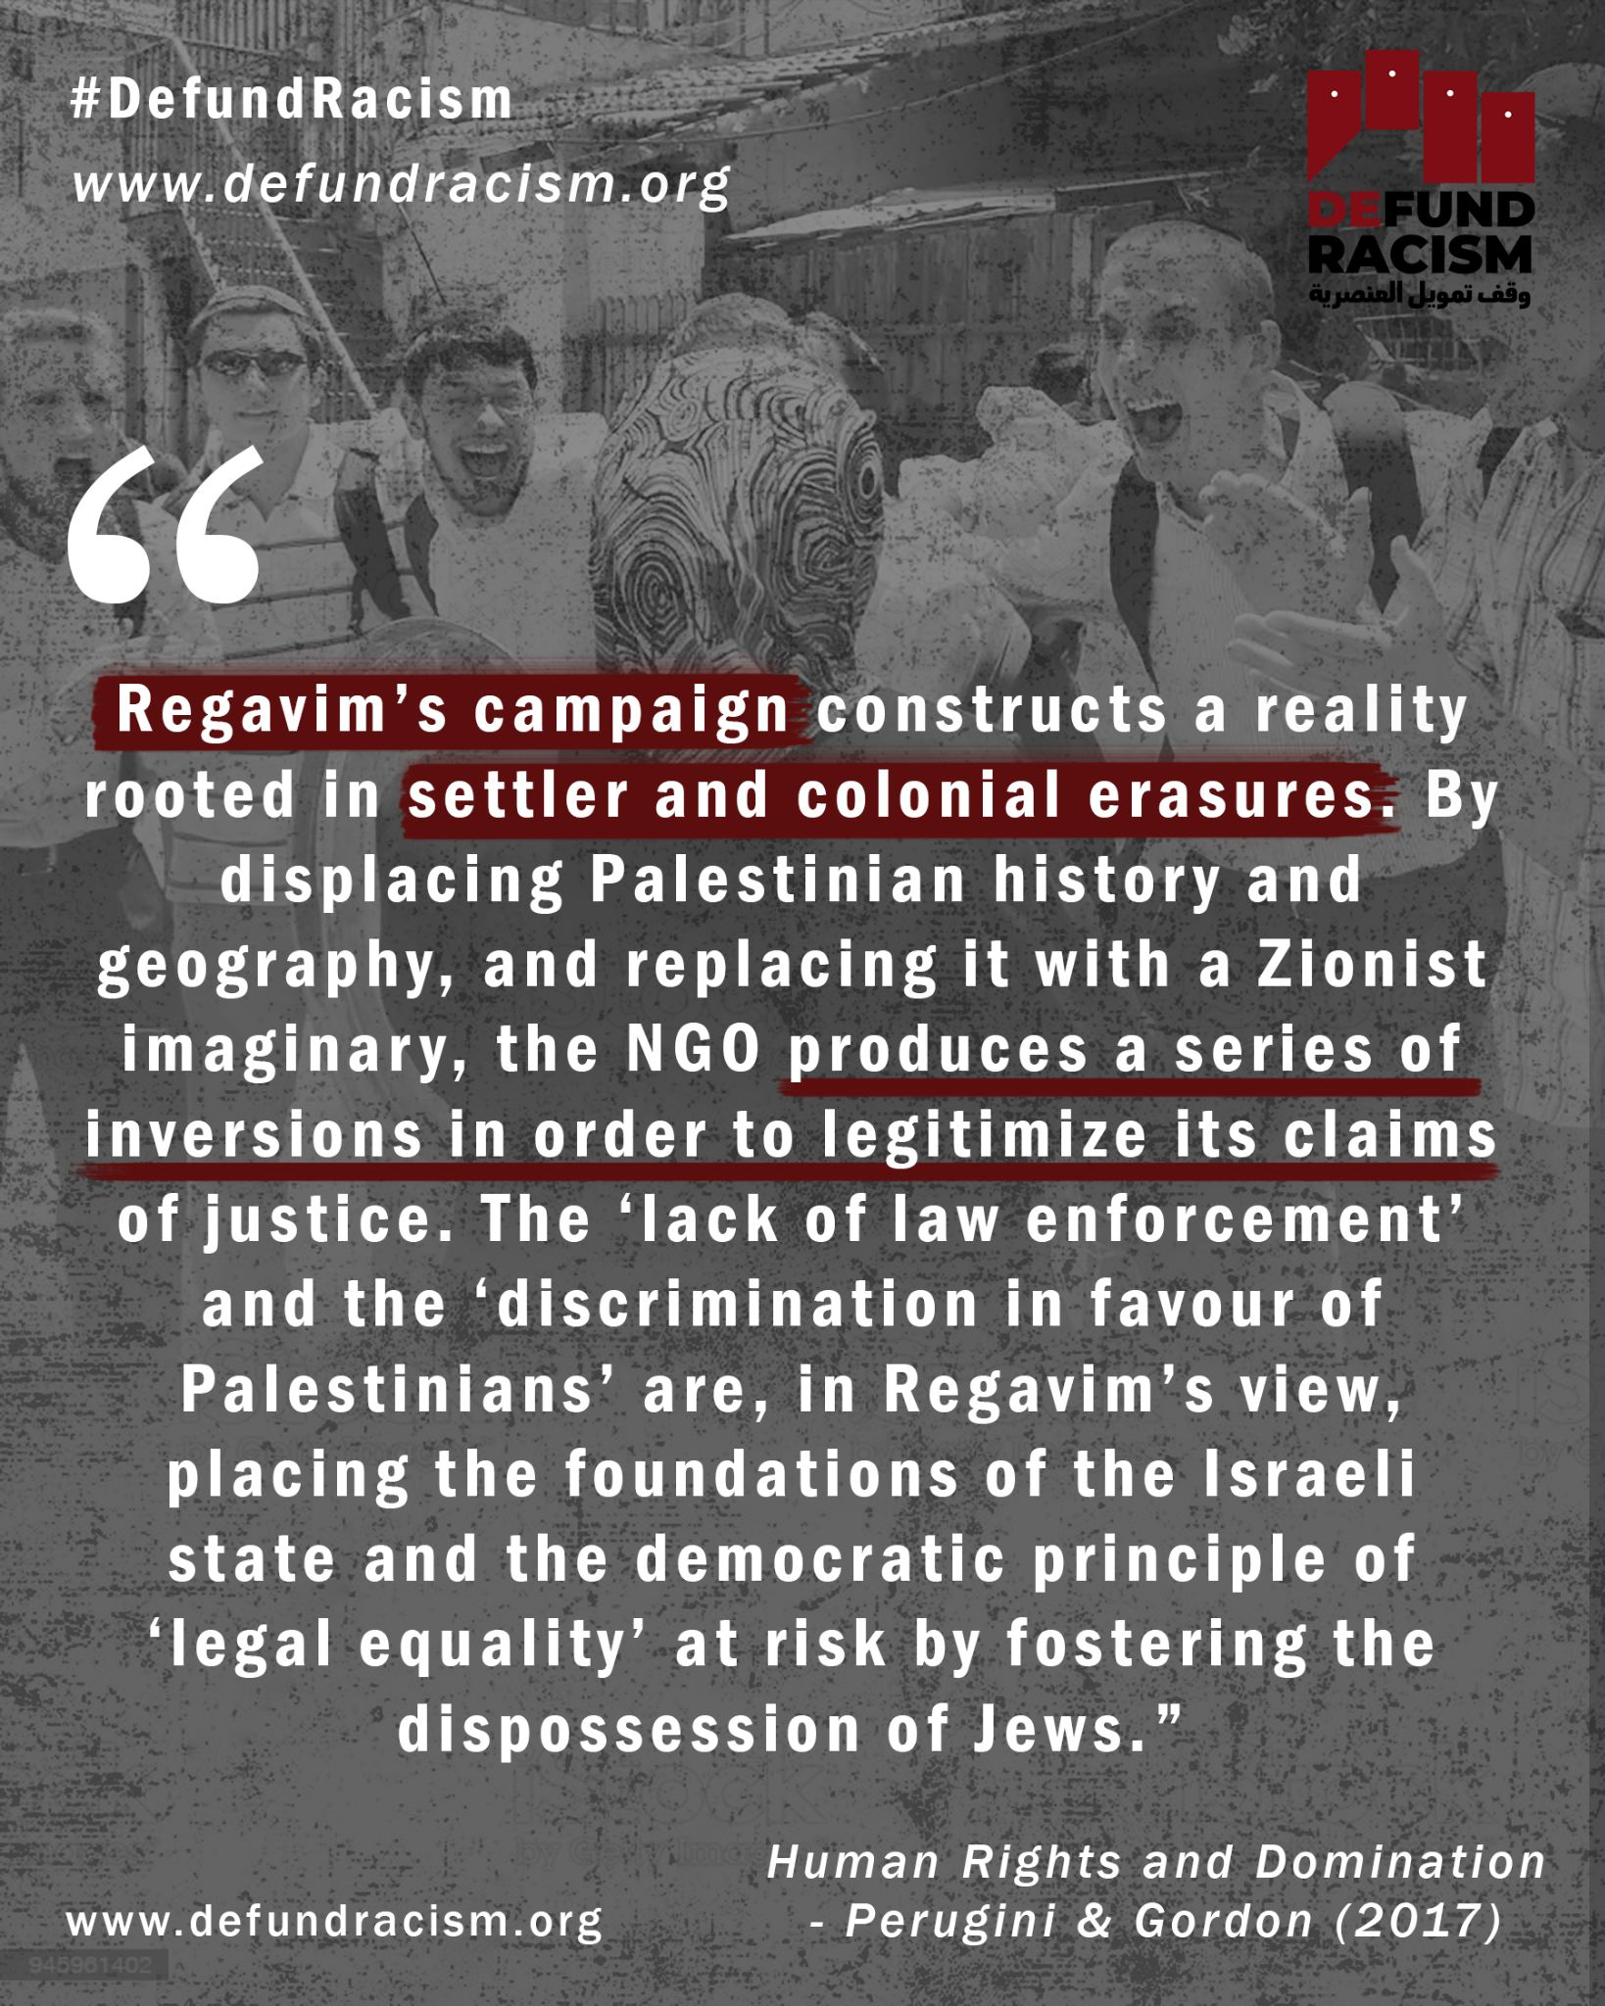 | Link  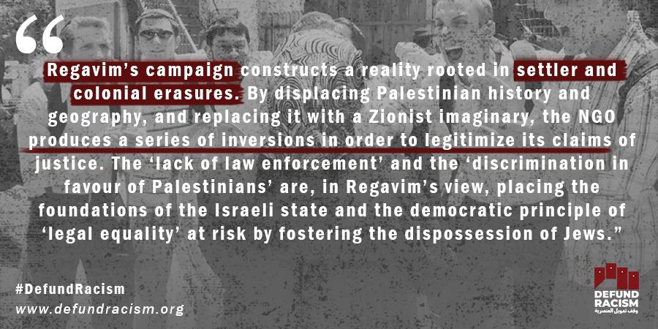 | Link  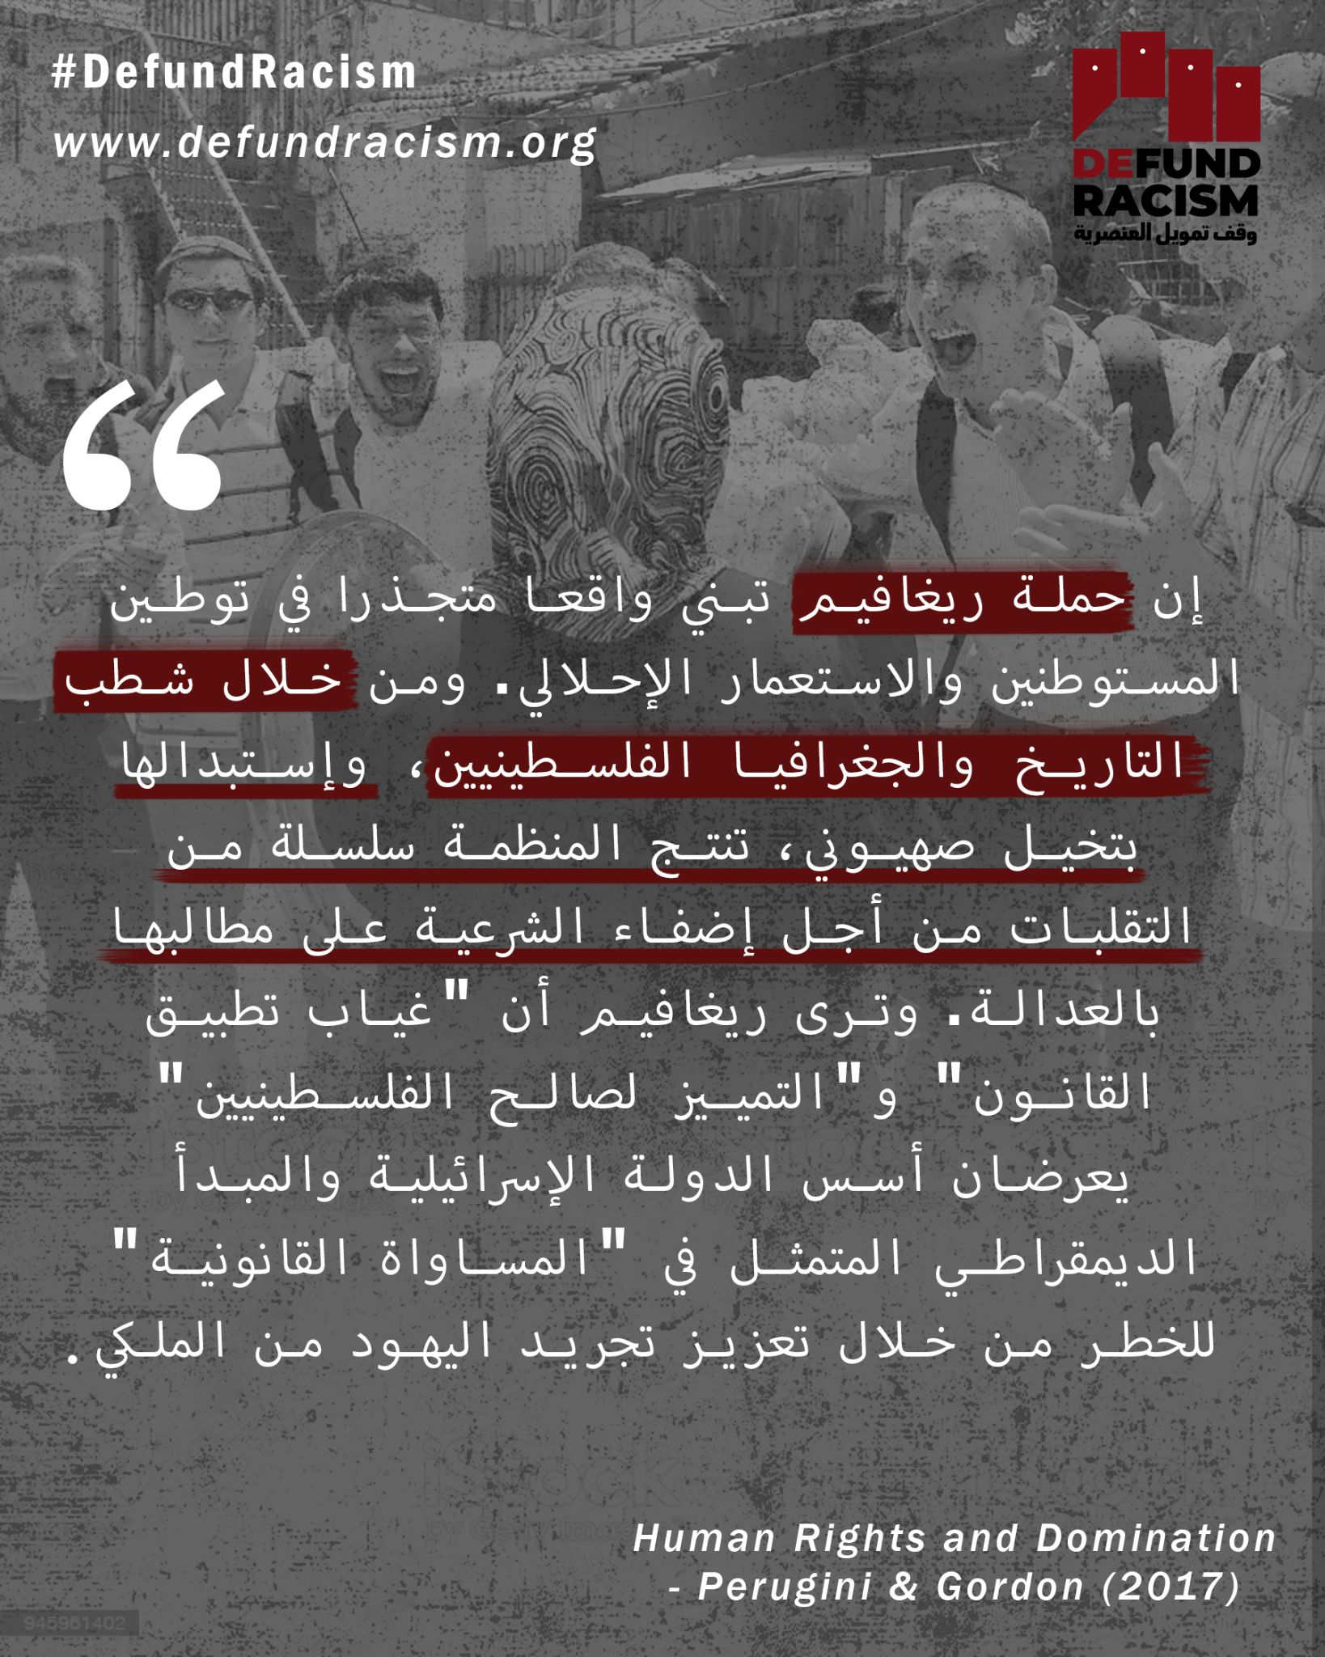
Week 3 | From Sheikh Jarrah and Silwan to Hebron and the Naqab, racist Israeli settler organizations work on the displacement of the indigenous Palestinian communities. Millions of US tax dollars flow into these organizations every year. But this isn't just about Palestinian resistance. The Southern Poverty Law Center has documented how white nationalists groups have also exploited the US nonprofit system to finance groups like the Proud Boys, for example. This campaign to decolonize the US nonprofit system is one way we can connect movements of resistance. It's one way we can combat antisemitism and colonialism simultaneously in meaningful ways that can result in structural changes.  We call an end to this funding of racism - all racism. Are you in?  defundracism.org  #DefundRacism  Photo: Christian Peacemaker Teams Palestine | من الشيخ جراح وسلوان إلى الخليل والنقب، تعمل منظمات المستوطنين الإسرائيليين العنصرية على تشريد المجتمعات الفلسطينية الأصلية. وتتدفق ملايين دولارات الضرائب الأمريكية إلى هذه المنظمات كل عام. لكن الأمر لا يتعلق فقط بالمقاومة الفلسطينية. وقد وثق “مركز قانون الفقر في الجنوب” كيف استغلت جماعات القوميين البيض أيضا النظام الأمريكي غير الربحي لتمويل جماعات مثل "براود بويز"، على سبيل المثال. هذه الحملة لإنهاء استعمار النظام الأمريكي غير الربحي هي إحدى الطرق التي يمكننا من خلالها ربط حركات المقاومة. إنها إحدى الطرق التي يمكننا بها مكافحة معاداة السامية والاستعمار في وقت واحد بطرق ذات مغزى يمكن أن تؤدي إلى تغييرات هيكلية.  وندعو إلى وضع حد لهذا التمويل للعنصرية - كل العنصرية. هل أنت معنا؟  defundracism.org  #DefundRacism | From Sheikh Jarrah & Silwan to Hebron & the Naqab, Israeli settler organizations receive millions of US tax dollars to displace indigenous Palestinian communities each year. But it's not just Palestinians being harmed - help us decolonize charitable laws. defundracism.org | From Sheikh Jarrah and Silwan to Hebron and the Naqab, racist Israeli settler organizations work on the displacement of the indigenous Palestinian communities. Millions of US tax dollars flow into these organizations every year. But this isn't just about Palestinian resistance. The Southern Poverty Law Center has documented how white nationalists groups have also exploited the US nonprofit system to finance groups like the Proud Boys, for example. This campaign to decolonize the US nonprofit system is one way we can connect movements of resistance. It's one way we can combat antisemitism and colonialism simultaneously in meaningful ways that can result in structural changes.  We call an end to this funding of racism - all racism. Are you in?  defundracism.org  #DefundRacism  Photo: Christian Peacemaker Teams Palestine | Link | Link | Link
Week 3 | Israeli settler organizations and their fiscal sponsors are registered as charities in New York. They exploit the US 501(c)(3) system to fund Israeli settlement expansion and, by definition, oppression of the indigenous people. Their activities are in violation of international law. Time to change that and #DefundRacism  defundracism.org | - إن منظمات المستوطنين الإسرائيليين ورعاتها الماليين مسجلون كجمعية خيرية في نيويورك. وهم يستغلون نظام الولايات المتحدة 501 (ج)(3) لتمويل التوسع الاستيطاني الإسرائيلي، وبتحديد اضطهاد السكان الأصليين. وأنشطتها تنتهك القانون الدولي. حان الوقت لتغيير ذلك #DefundRacism  defundracism.org | Israel: Ateret Cohanim, "keep a united Jerusalem in Jewish hands."  USA: VDare, "Diversity per se is not strength, but a vulnerability."  Both manipulate the US charitable system to finance programs of dominance. #DefundRacism in Palestine & Turtle Island. defundracism.org | Israeli settler organizations and their fiscal sponsors are registered as charities in New York. They exploit the US 501(c)(3) system to fund Israeli settlement expansion and, by definition, oppression of the indigenous people. Their activities are in violation of international law. Time to change that and #DefundRacism  defundracism.org | Link | Link | Link
Week 4 | Israeli settler organizations' tactics to displace and replace Palestinians are nothing new. The settler-colonial project was premised on exploiting foreign support. Elad, the Israel Land Fund, and Ateret Cohanim are the main drivers behind the violence in Jerusalem. They have amassed power and resources through the exploitation of US charitable laws. We call on the New York Attorney General to stop exploiting the US charitable system to finance apartheid and ethnic cleansing. #DefundRacism defundracism.org | إن أساليب منظمات المستوطنين الإسرائيلية في تشريد الفلسطينيين واستبدالهم ليست بالأمر الجديد. وكان المشروع الاستيطاني الاستعماري يقوم على استغلال الدعم الأجنبي. ويعتبر "العاد" وصندوق الأراضي الاسرائيلي و"عطيريت كوهانيم" المحركين الرئيسيين وراء أعمال العنف في القدس. لقد جمعوا السلطة والموارد من خلال استغلال القوانين الخيرية الأمريكية. وندعو المدعي العام في نيويورك إلى التوقف عن استغلال النظام الخيري الأمريكي لتمويل الفصل العنصري والتطهير العرقي. #DefundRacism defundracism.org | Elad, the Israel Land Fund, & Ateret Cohanim have amassed power & resources by exploiting US charitable laws. We call on the New York Attorney General to enforce the law US charitable and stop the financing of apartheid and ethnic cleansing. #DefundRacism defundracism.org | Israeli settler organizations' tactics to displace and replace Palestinians are nothing new. The settler-colonial project was premised on exploiting foreign support. Elad, the Israel Land Fund, and Ateret Cohanim are the main drivers behind the violence in Jerusalem. They have amassed power and resources through the exploitation of US charitable laws. We call on the New York Attorney General to stop exploiting the US charitable system to finance apartheid and ethnic cleansing. #DefundRacism defundracism.org | Link  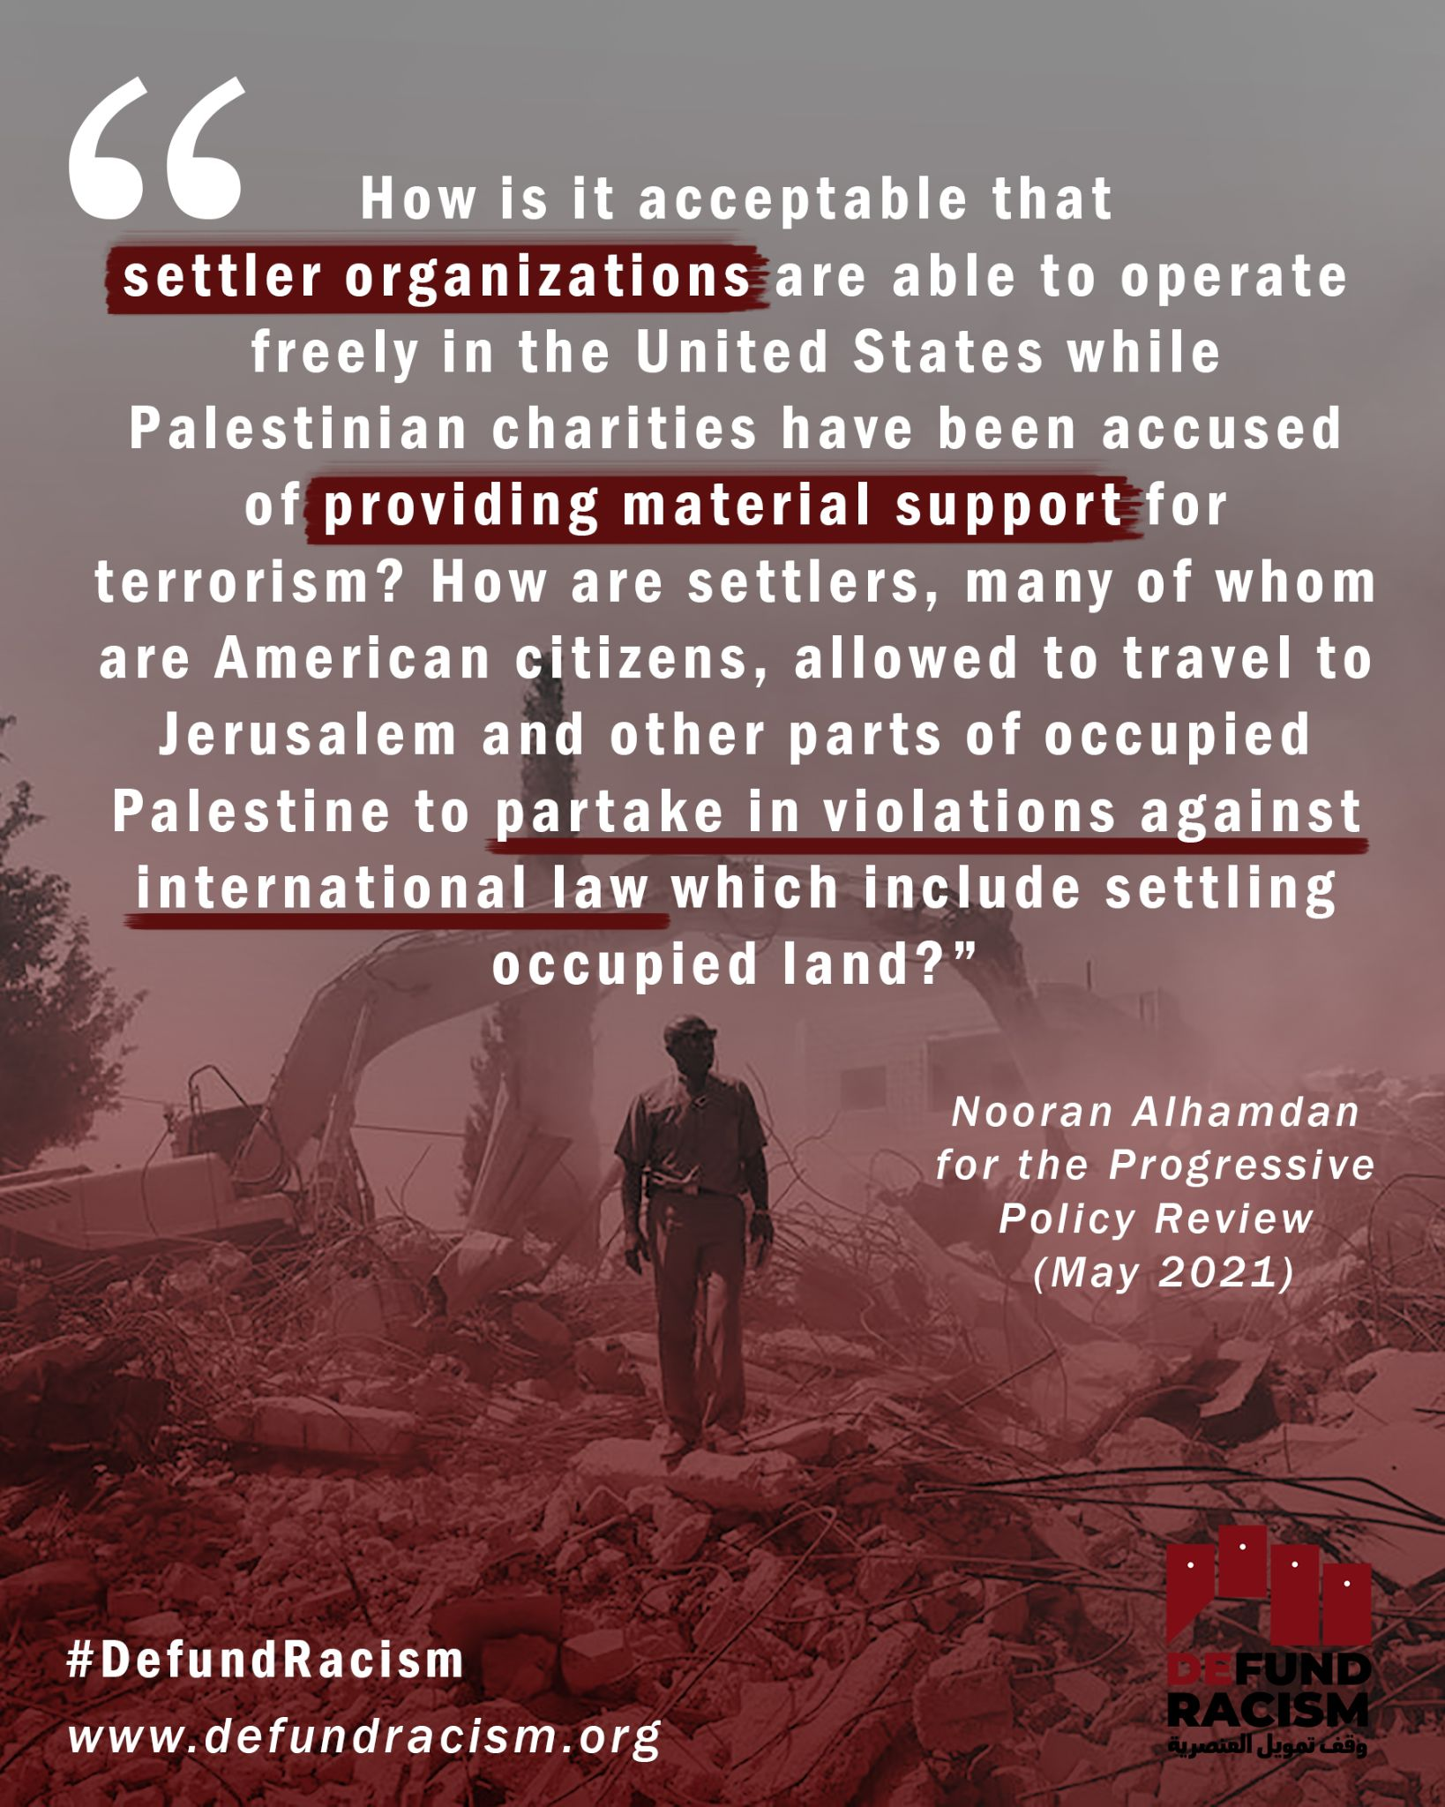 | Link  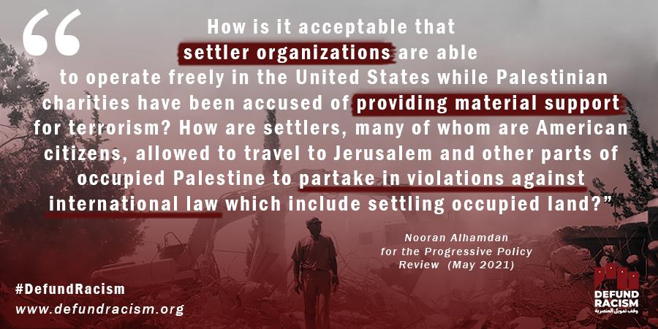 | Link  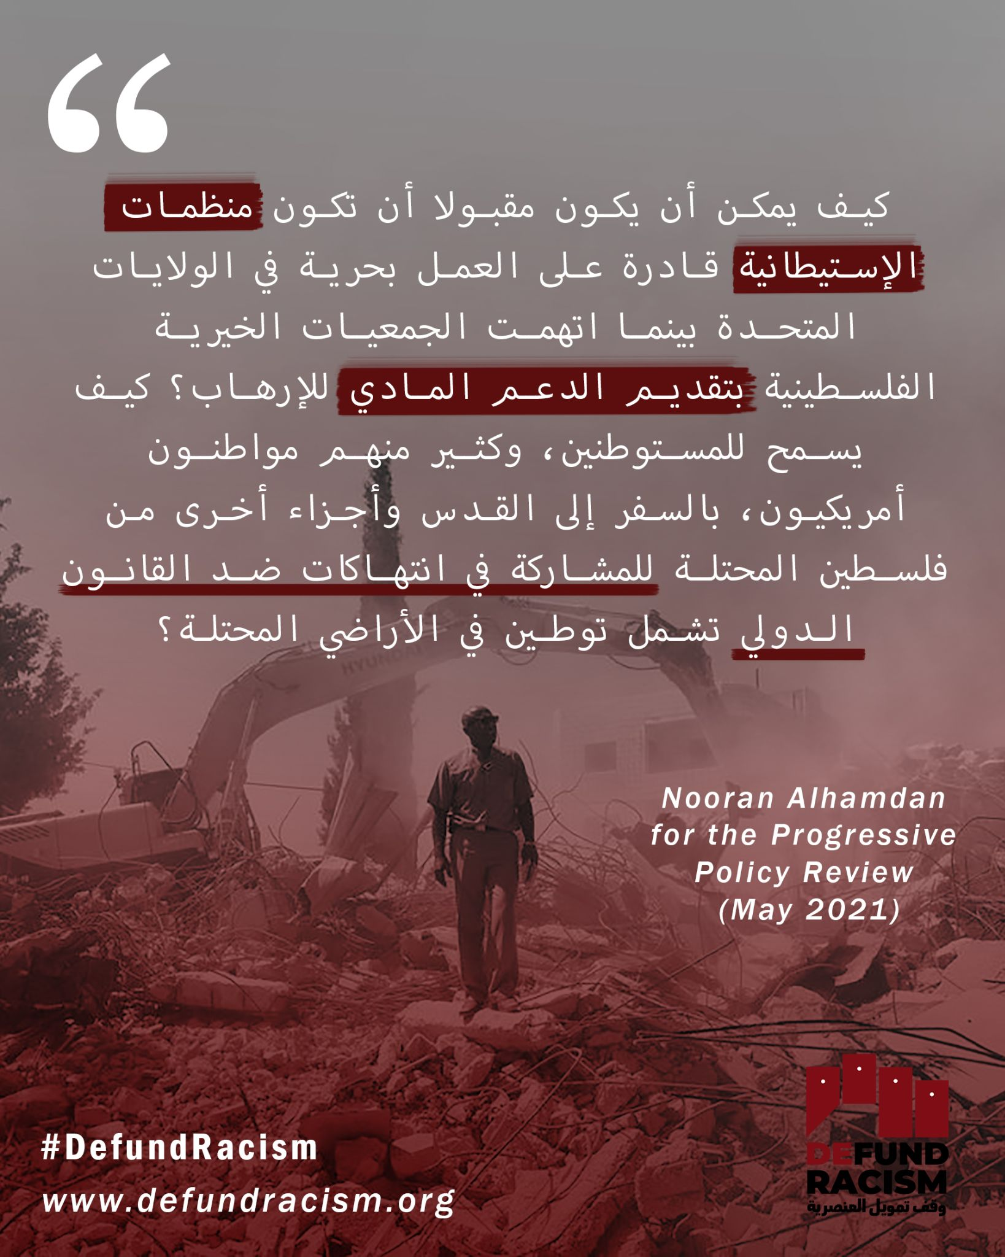
Week 4 | Ateret Cohanim is a Jerusalem-based settler organization working to build a Jewish demographic majority in Jerusalem’s old city and East Jerusalem by replacing the Palestinian residents of Jerusalem with Jewish settlers.  This racist work is funded by charitable tax money, flowing through their New York-based fiscal sponsor - American Friends of Ateret Cohanim.  Settler-colonialism, racism, and apartheid are NOT charitable purposes. We demand the revocation of their charitable status. Join us in demanding New York Attorney General Letitia James enforce the law and revoke their license.  defundracism.org  #DefundRacism  Photo: AFP | عطيريت كوهانيم هي منظمة مستوطنة مقرها القدس تعمل على بناء غالبية سكانية يهودية في المدينة القديمة والقدس الشرقية من خلال استبدال السكان الفلسطينيين في القدس بمستوطنين يهود.  يتم تمويل هذا العمل العنصري من أموال الضرائب الخيرية، التي تتدفق من خلال راعيها المالي في نيويورك - أصدقاء أتريت كوهانيم الأمريكيين.  إن الاستعمار الاستيطاني والعنصرية والفصل العنصري ليست أغراضا خيرية. ونحن نطالب بإلغاء وضعهم الخيري. انضم إلينا في مطالبة المدعية العامة في نيويورك ليتيتيا جيمس بتطبيق القانون وإلغاء رخصتهم الخيرية.  defundracism.org  #DefundRacism | Ateret Cohanim is a Jerusalem-based settler organization working to build a Jewish demographic majority in Jerusalem’s old city & East Jerusalem by replacing the Palestinian residents of Jerusalem with Jewish settlers. These racist efforts are NOT charity. defundracism.org | Ateret Cohanim is a Jerusalem-based settler organization working to build a Jewish demographic majority in Jerusalem’s old city and East Jerusalem by replacing the Palestinian residents of Jerusalem with Jewish settlers.  This racist work is funded by charitable tax money, flowing through their New York-based fiscal sponsor - American Friends of Ateret Cohanim.  Settler-colonialism, racism, and apartheid are NOT charitable purposes. We demand the revocation of their charitable status. Join us in demanding New York Attorney General Letitia James enforce the law and revoke their license.  defundracism.org  #DefundRacism  Photo: AFP | Link  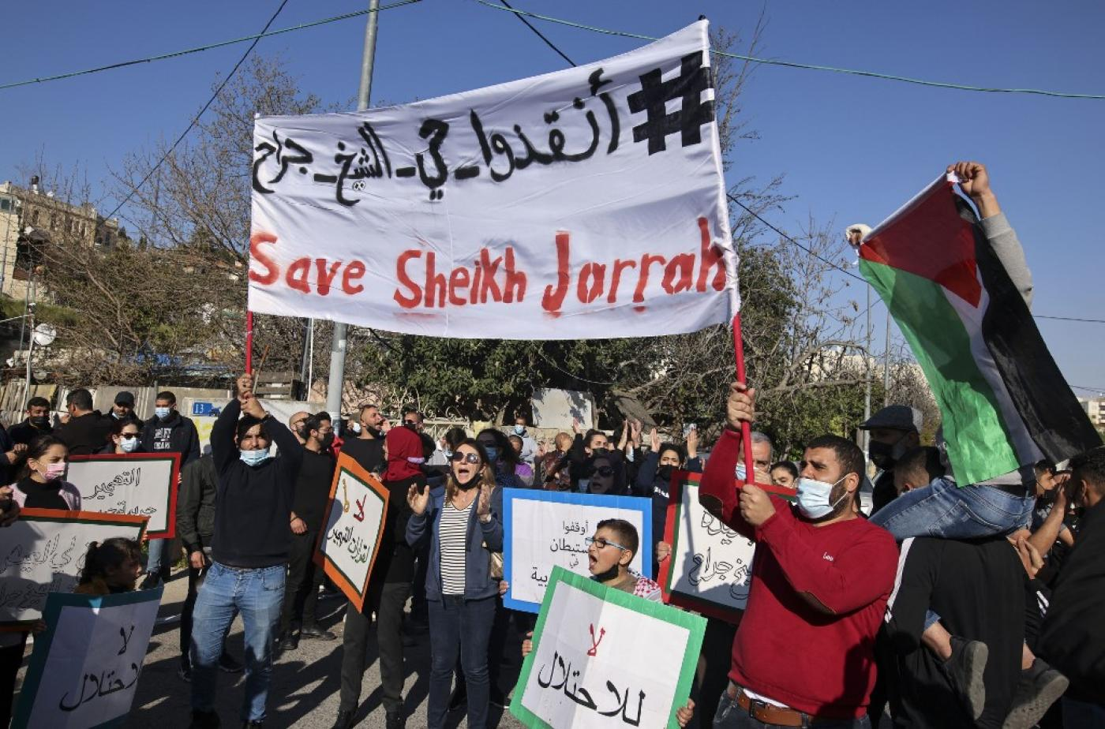 | Link | Link
Week 4 | Richard Spencer has used the National Policy Institute, a nonprofit, to advocate for an "ethnostate" that would be a "safe space" for white people. Disgusting, right?  You know who also says this? The Israel Land Fund: "House by house, lot by lot, the Israel Land Fund is ensuring the land of Israel stays in the hands of the Jewish people forever." Both organizations exploit US charitable laws to finance a system of dominance over black, brown, and indigenous peoples. Join us in the call to #DefundRacism defundracism.org | استخدم ريتشارد سبنسر معهد السياسة الوطنية، وهو منظمة غير ربحية، للدعوة إلى "دولة عرقية" من شأنها أن تكون "مساحة آمنة" للبيض. مثير للاشمئزاز، أليس كذلك؟  هل تعرف من يقول هذا أيضا؟ صندوق الأراضي الإسرائيلي: "صندوق الأراضي الإسرائيلية يضمن الأرض الإسرائيلية، منزلا منزلا، الكثير بالقرعة، بقاء أرض إسرائيل في أيدي الشعب اليهودي إلى الأبد". تستغل المنظمتان القوانين الخيرية الأمريكية لتمويل نظام الهيمنة على الشعوب السوداء والبنية والسكان الأصليين. انضم إلينا الدعوة إلى #DefundRacism defundracism.org | Richard Spencer & National Policy Institute advocate for an "ethnostate" & "safe space" for white people.  The Israel Land Fund: "ILF is ensuring the land of Israel stays in the hands of the Jewish people forever." Both are US charities. Time to defundracism.org | Richard Spencer has used the National Policy Institute, a nonprofit, to advocate for an "ethnostate" that would be a "safe space" for white people. Disgusting, right?  You know who also says this? The Israel Land Fund: "House by house, lot by lot, the Israel Land Fund is ensuring the land of Israel stays in the hands of the Jewish people forever." Both organizations exploit US charitable laws to finance a system of dominance over black, brown, and indigenous peoples. Join us in the call to #DefundRacism defundracism.org | Link  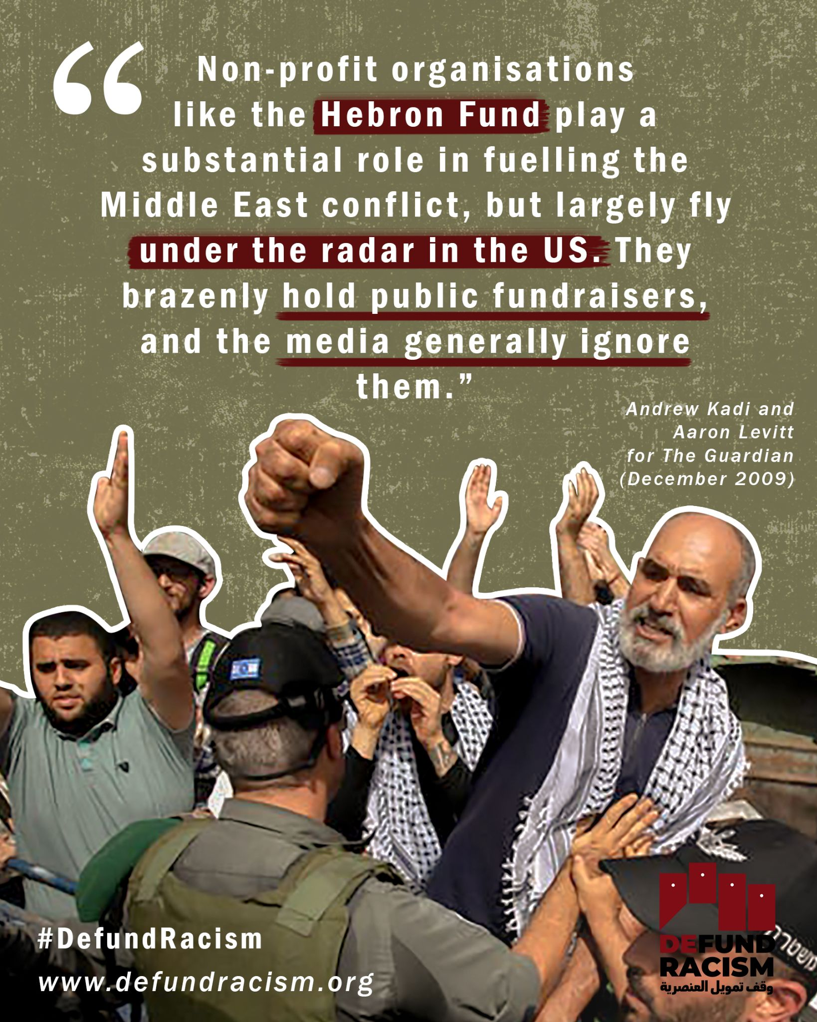 | Link  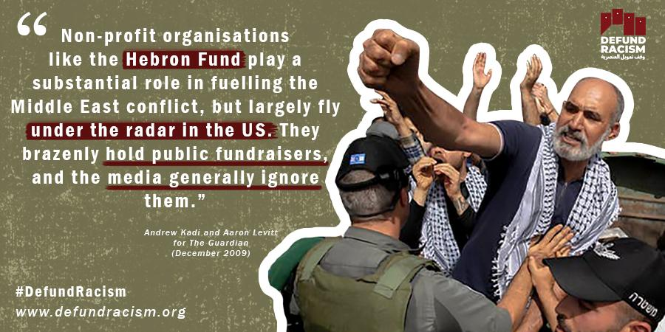 | Link  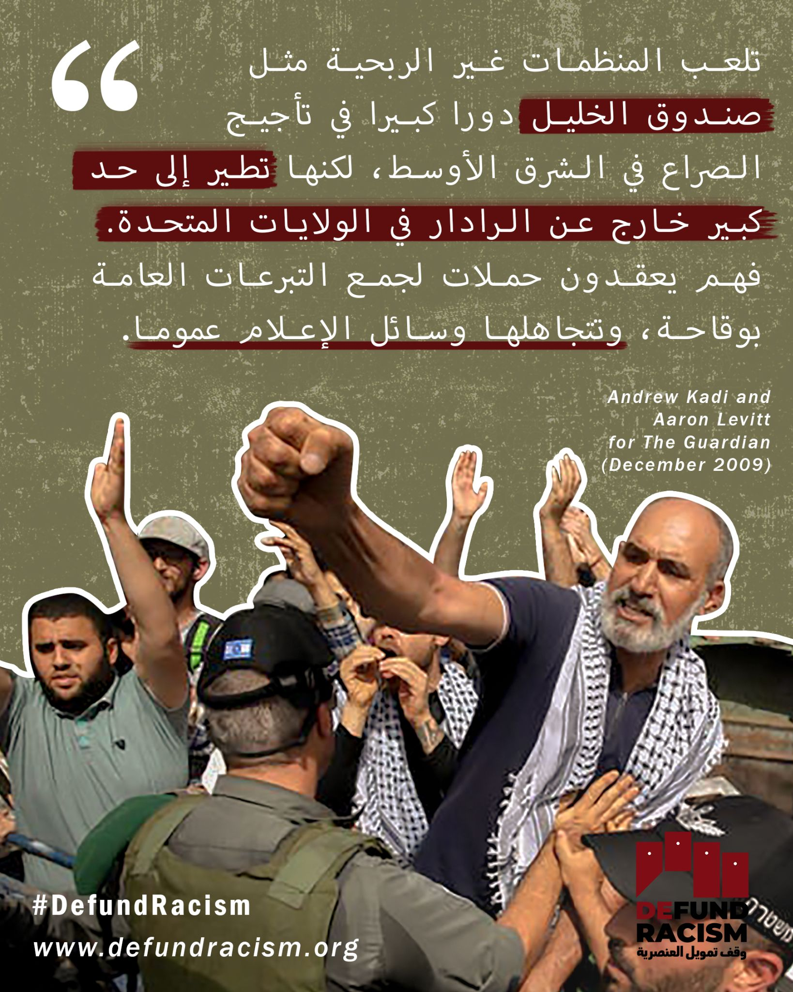
Week 5 | Solidarity with Palestine means targeting the underlying structures of Israel's settler-colonial project. Every year, US charities funnel millions of dollars to finance the settler organizations like Elad, Regavim, Ateret Cohanim, the Hebron Fund, and more.  Unlike other campaigns which have appealed to the IRS or the Treasury Department, we are demanding that an elected official - New York State Attorney General Letitia James - investigate and revoke the charitable licenses of nonprofits actively financing Israel's system of apartheid. AG Letitia James has constituents to stand with, and now is the time to make this happen.  Sign and share our petition, be loud, and make clear that racism is not a part of charitable work!  defundracism.org #DefundRacism | التضامن مع فلسطين يعني استهداف الهياكل الأساسية لمشروع إسرائيل الاستيطاني الاستعماري. وفي كل عام، توجه الجمعيات الخيرية الأميركية ملايين الدولارات لتمويل منظمات المستوطنين مثل إلعاد، وريغافيم، وعطيريت كوهانيم، وصندوق الخليل، وأكثر من ذلك.  وخلافا للحملات الأخرى التي ناشدت مصلحة الضرائب أو وزارة الخزانة الأمريكية، فإننا نطالب مسؤولا منتخبا - المدعية العامة لولاية نيويورك ليتيتيا جيمس - بالتحقيق في التراخيص الخيرية للمنظمات غير الربحية التي تمول بنشاط نظام الفصل العنصري الإسرائيلي وإلغاءها. AG ليتيتيا جيمس لديه مكونات للوقوف مع، والآن هو الوقت المناسب لتحقيق ذلك.  وقع وشارك عريضتنا، وكن صاخبا، وأوضح أن العنصرية ليست جزءا من العمل الخيري!  defundracism.org #DefundRacism | Solidarity with Palestine means targeting the underlying structures of Israel's settler-colonial project. Every year, US charities funnel millions of $$ to finance the settler organizations like Elad, Ateret Cohanim, & the Hebron Fund. Join the campaign to defundracism.org | Solidarity with Palestine means targeting the underlying structures of Israel's settler-colonial project. Every year, US charities funnel millions of dollars to finance the settler organizations like Elad, Regavim, Ateret Cohanim, the Hebron Fund, and more.  Unlike other campaigns which have appealed to the IRS or the Treasury Department, we are demanding that an elected official - New York State Attorney General Letitia James - investigate and revoke the charitable licenses of nonprofits actively financing Israel's system of apartheid. AG Letitia James has constituents to stand with, and now is the time to make this happen.  Sign and share our petition, be loud, and make clear that racism is not a part of charitable work!  defundracism.org #DefundRacism | Link  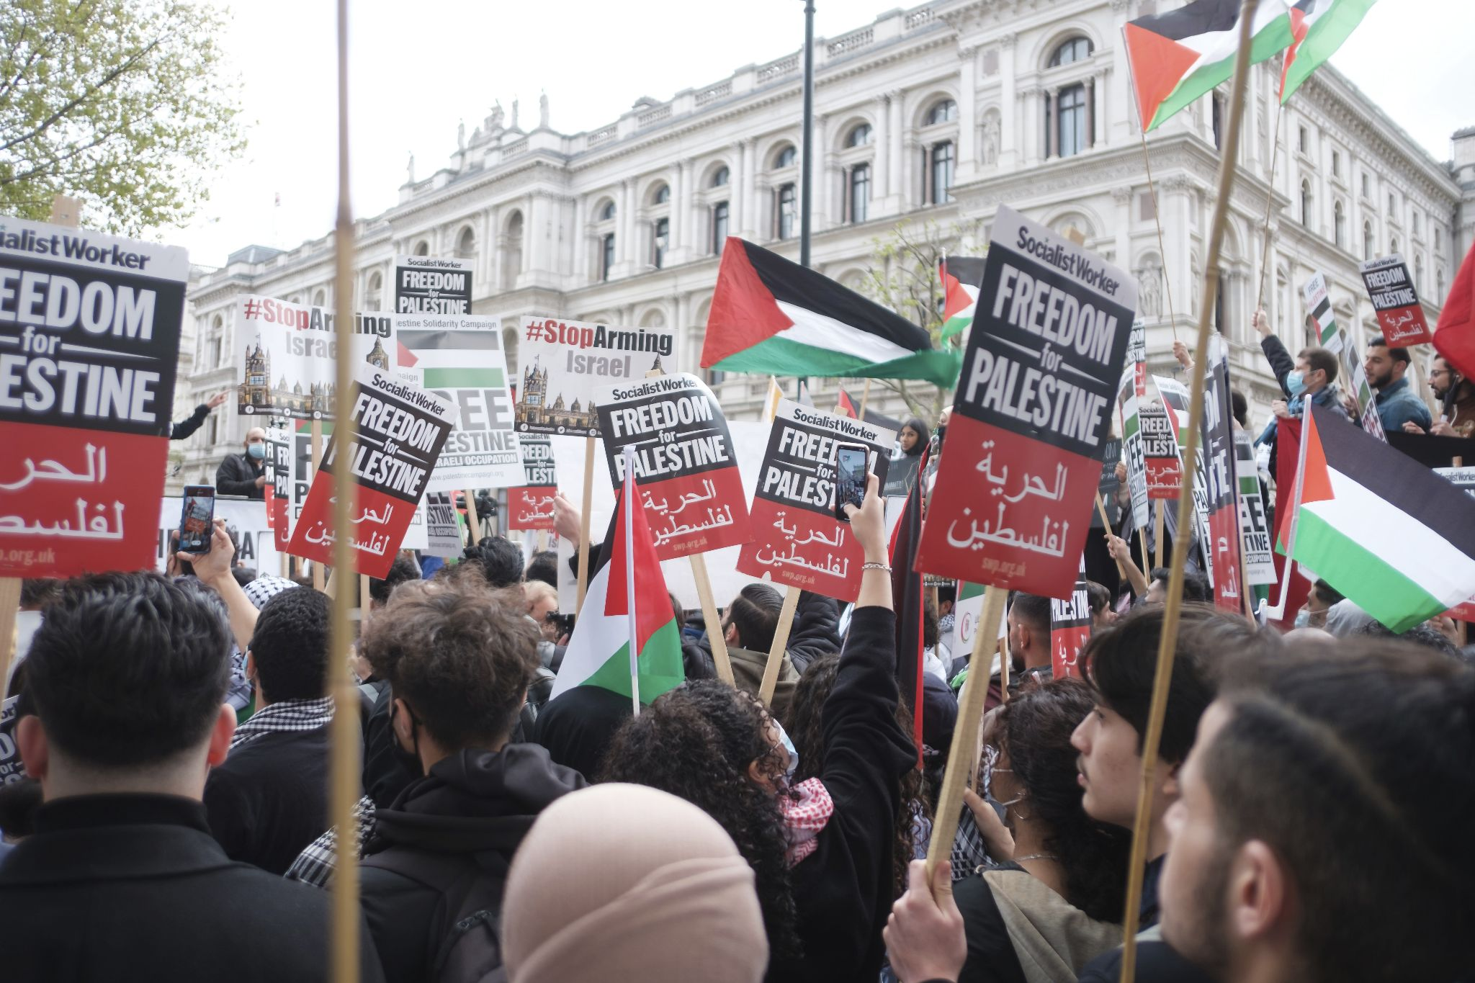 | Link | Link
Week 5 | Nowhere is Israel's system of apartheid so obvious as it is in Hebron, where the Israeli squatter movement has designed a system of domination over the indigenous community. Israel maintains this matrix of violence with over 100 roadblocks, military checkpoints, and home closures to ensure that the small, embattled Palestinian community is regulated into ethnic enclaves.  The largest known funder of the settlement in Hebron is the New York-based Hebron Fund. In our campaign to #DefundRacism we call on the New York State Attorney General Letitia James to revoke the Hebron Funds’ charitable status. Funding settlements and violence is not charitable work.  Join our call and demand the defunding of the Hebron Fund and other racist organizations funneling money into apartheid.  defundracism.org | لا يوجد في أي مكان نظام الفصل العنصري الإسرائيلي واضح كما هو الحال في الخليل، حيث صممت حركة المستوطنين الإسرائيليين نظام هيمنة على مجتمع السكان الأصليين. تحتفظ إسرائيل بمصفوفة العنف هذه مع أكثر من 100 حاجز، ونقاط تفتيش عسكرية، وإغلاق المنازل لضمان تنظيم المجتمع الفلسطيني الصغير المحاصر إلى جيوب عرقية.  وأكبر ممول معروف للمستوطنة في الخليل هو صندوق الخليل الذي يتخذ من نيويورك مقرا له  .  ندعو المدعية العامة لولاية نيويورك ليتيتيا جيمس  إلى إلغاء الحالة الخيرية لصناديق الخليل. تمويل المستوطنات والعنف ليس عملا خيريا.  انضموا إلى دعوتنا وطالبوا بإلغاء تمويل صندوق الخليل وغيره من المنظمات العنصرية التي توجه الأموال إلى الفصل العنصري.  defundracism.org | Nowhere is Israel's system of apartheid as obvious as in Hebron, where the Israeli squatter movement has designed a system of domination over the indigenous community. This matrix of violence exists today - at least in part - due to the Hebron Fund. defundracism.org | Nowhere is Israel's system of apartheid so obvious as it is in Hebron, where the Israeli squatter movement has designed a system of domination over the indigenous community. Israel maintains this matrix of violence with over 100 roadblocks, military checkpoints, and home closures to ensure that the small, embattled Palestinian community is regulated into ethnic enclaves.  The largest known funder of the settlement in Hebron is the New York-based Hebron Fund. In our campaign to #DefundRacism we call on the New York State Attorney General Letitia James to revoke the Hebron Funds’ charitable status. Funding settlements and violence is not charitable work.  Join our call and demand the defunding of the Hebron Fund and other racist organizations funneling money into apartheid.  defundracism.org | Link  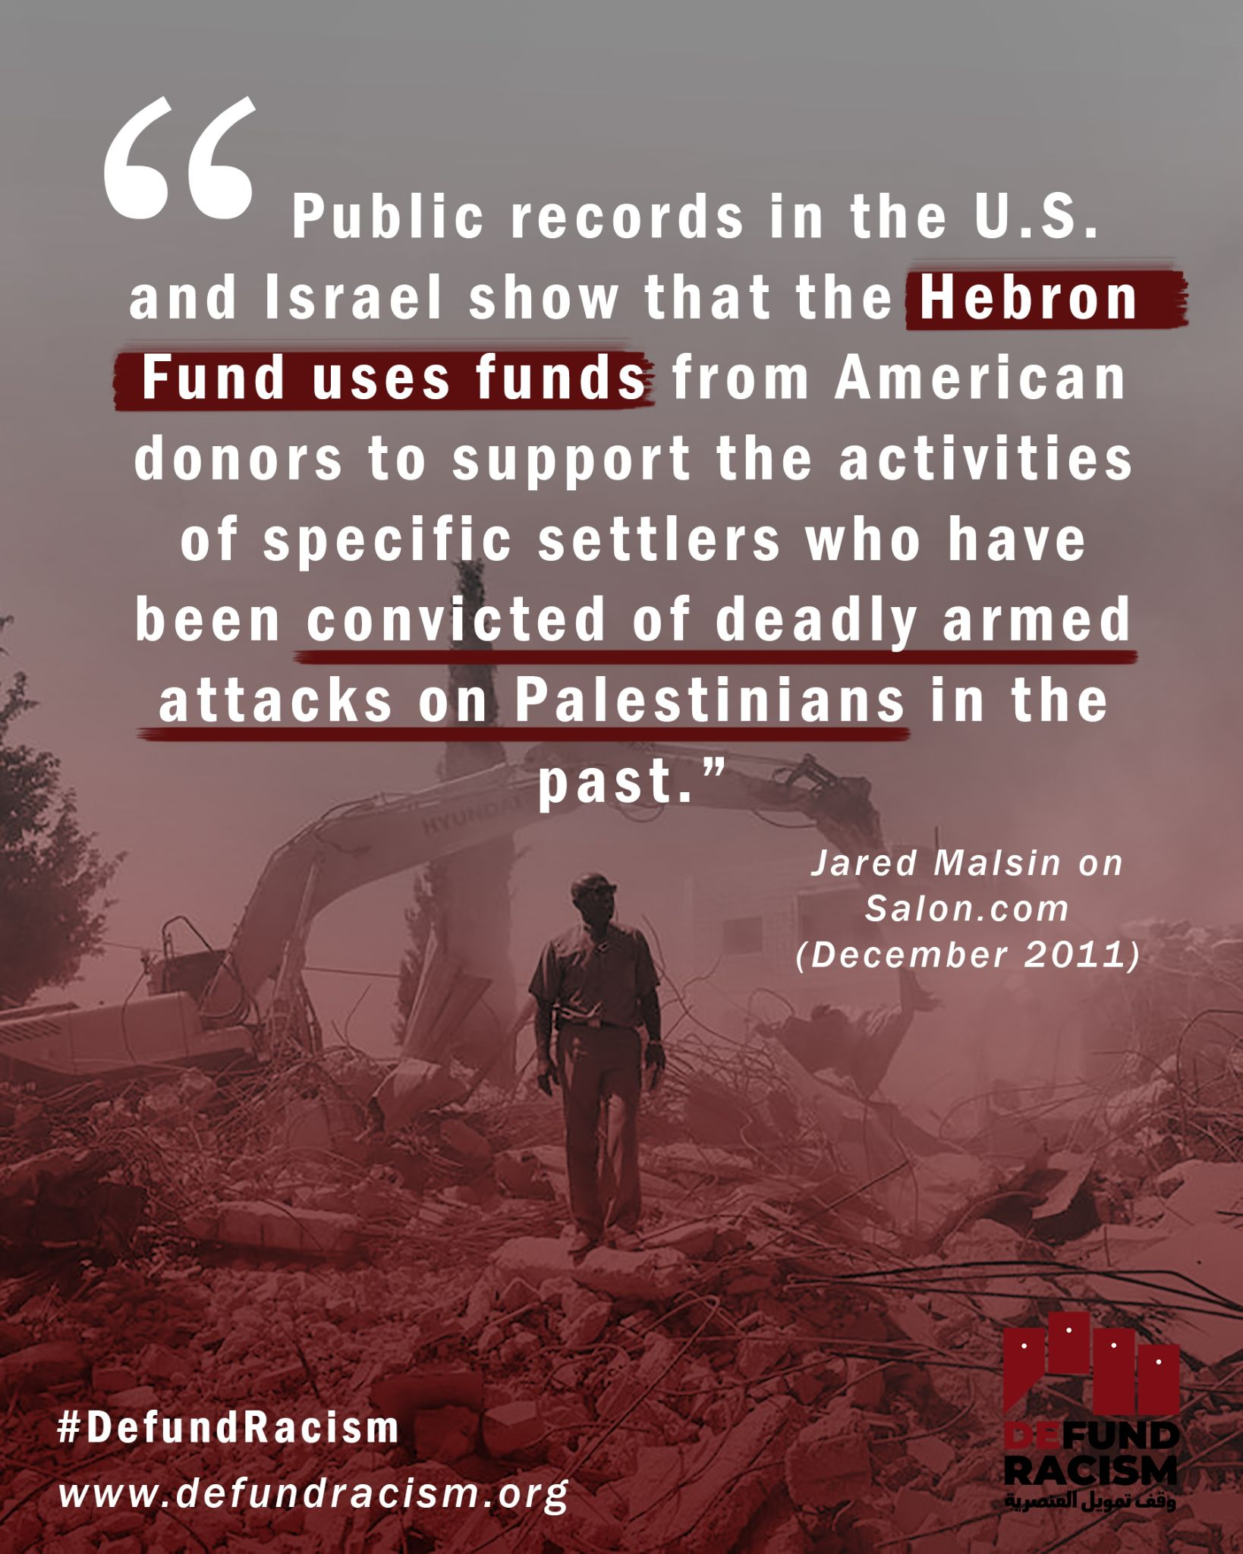 | Link  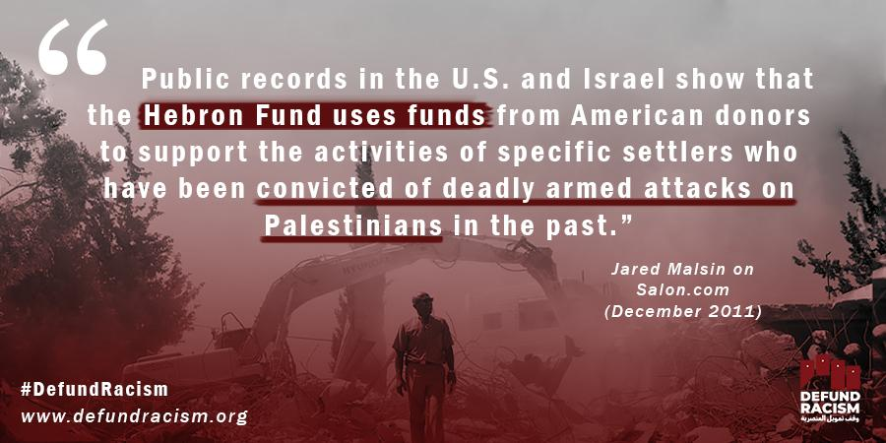 | Link
Week 5 | New York residents know what gentrification looks and feels like: marginalized communities are pushed out of their neighborhoods to make way for new buildings and new residents.  For Palestinians, colonization of their neighborhoods and villages looks much the same. Except that in many cases, the funding for Palestinians’ displacement comes from organizations funded by US charities, and US citizens’ tax-deductible donations to those charities.  This is what the Israel Land Fund does. Luckily, US voters have a say in what “charity” means. Stand up, sign and share our call to #DefundRacism.  defundracism.org | يعرف سكان نيويورك كيف يبدو الإحلال الطبقي الممنهج (السراوة) ويشعرون به: يتم طرد المجتمعات المهمشة من أحيائهم لإفساح المجال للمباني الجديدة والسكان الجدد.  بالنسبة للفلسطينيين، يبدو استعمار أحيائهم وقراهم متشابها إلى حد كبير. إلا أن تمويل تهجير الفلسطينيين يأتي في كثير من الحالات من منظمات تمولها جمعيات خيرية أمريكية، وتبرعات المواطنين الأمريكيين المعفاة من الضرائب لتلك الجمعيات الخيرية.  هذا ما يفعله صندوق الأراضي الإسرائيلي. ومن حسن الحظ أن الناخبين في الولايات المتحدة لهم رأي في ما تعنيه كلمة "صدقة". قف، وقع وشارك دعوتنا إلى #DefundRacism. | NY residents know what gentrification looks & feels like: marginalized communities pushed out of their neighborhoods to make way for new residents.  For Palestinians, colonization looks quite similar. Colonization & gentrification =/= charity. #DefundRacism defundracism.org | New York residents know what gentrification looks and feels like: marginalized communities are pushed out of their neighborhoods to make way for new buildings and new residents.  For Palestinians, colonization of their neighborhoods and villages looks much the same. Except that in many cases, the funding for Palestinians’ displacement comes from organizations funded by US charities, and US citizens’ tax-deductible donations to those charities.  This is what the Israel Land Fund does. Luckily, US voters have a say in what “charity” means. Stand up, sign and share our call to #DefundRacism.  defundracism.org | Link  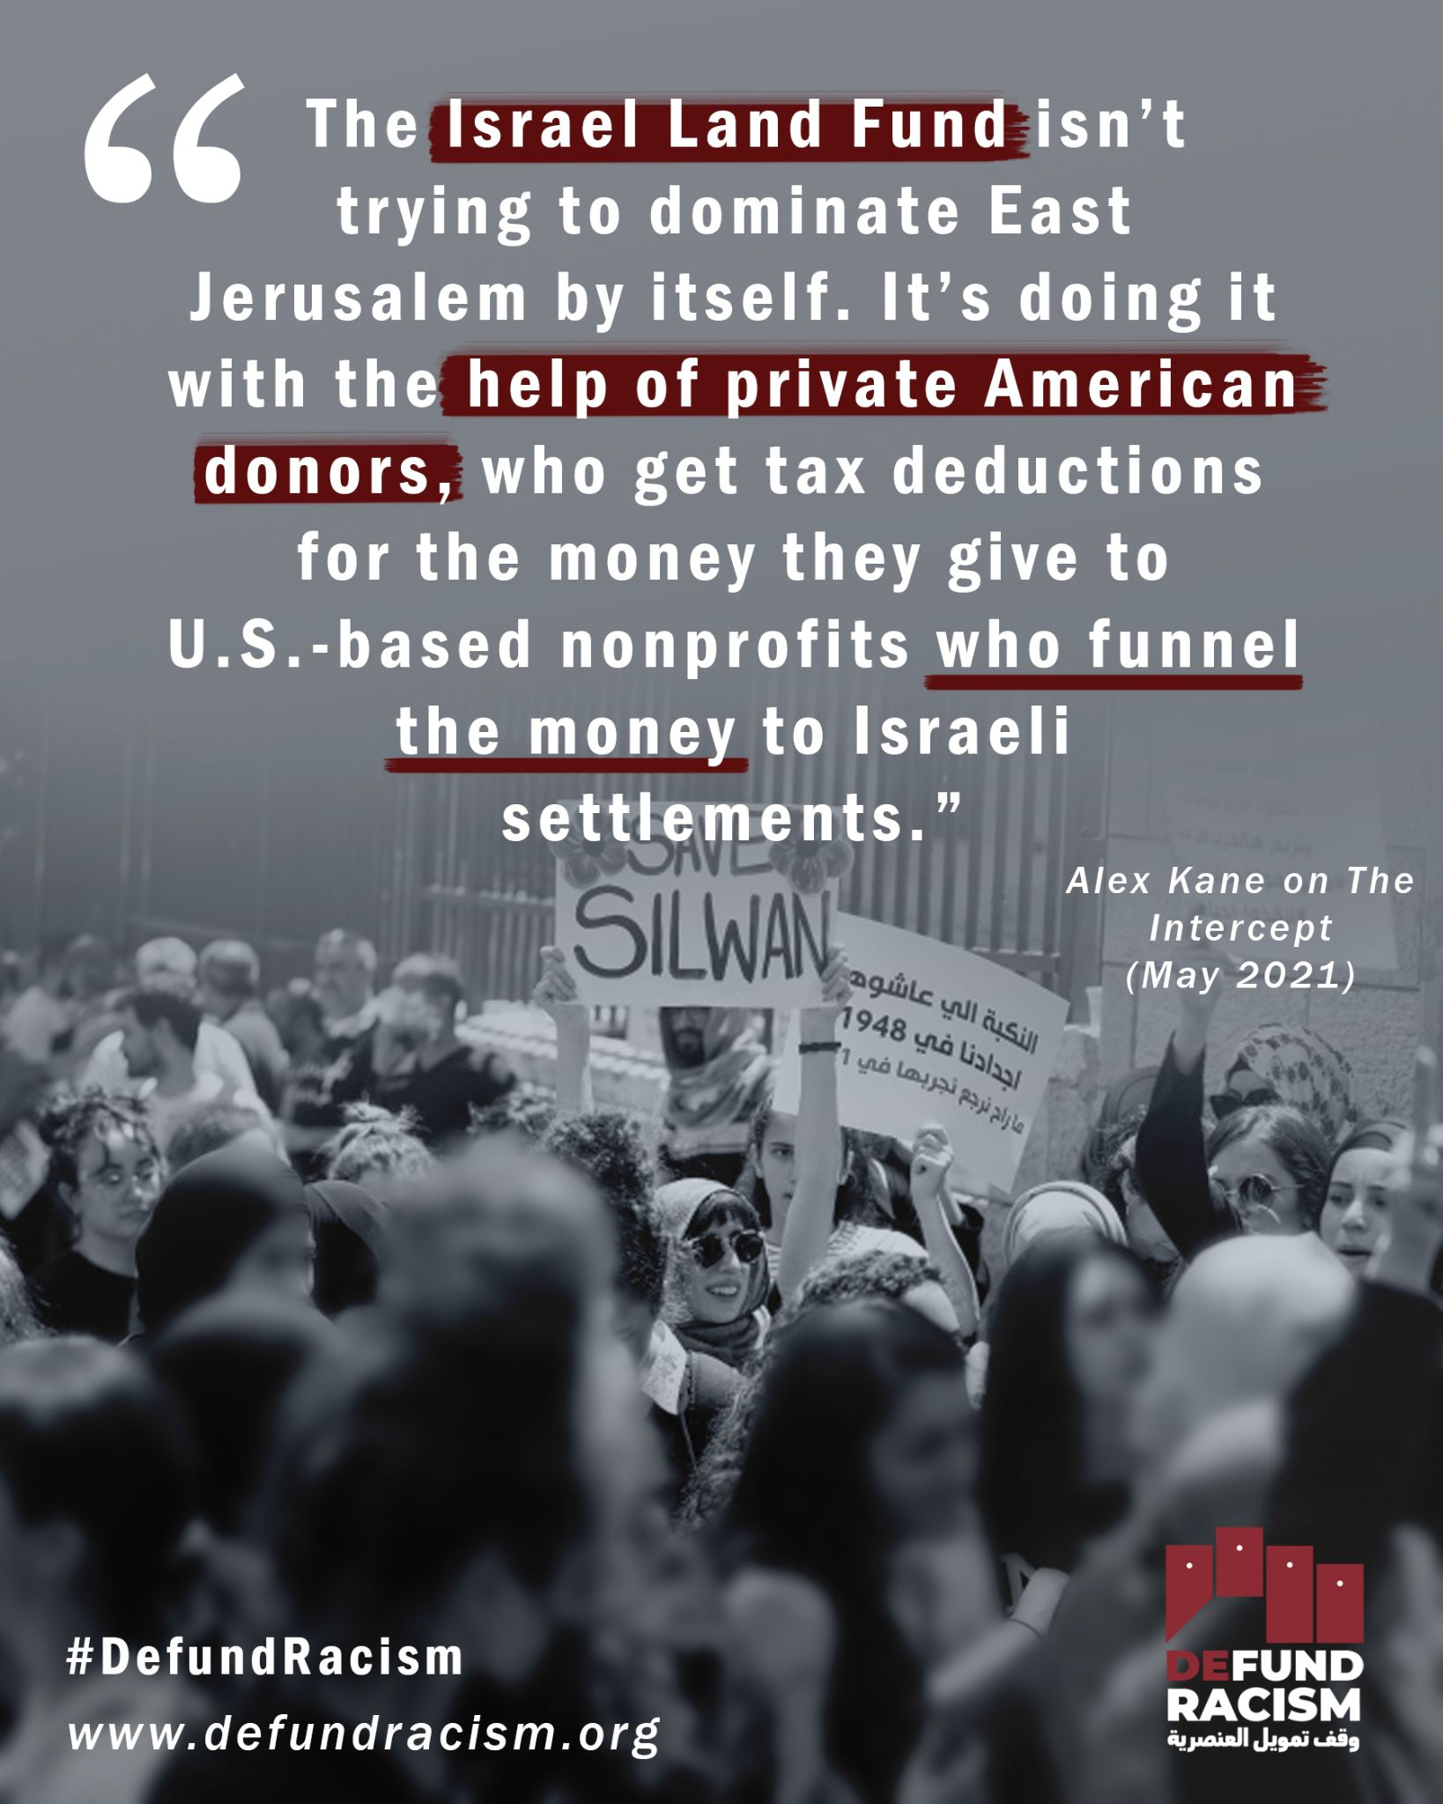 | Link  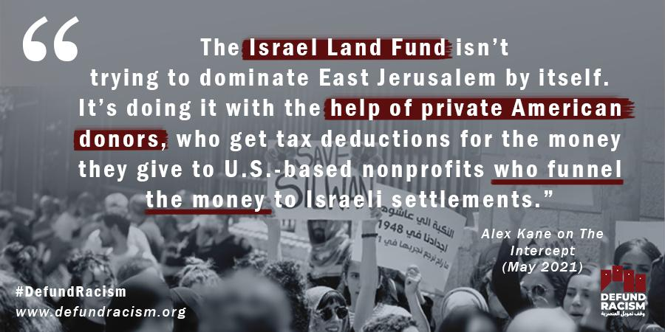 | Link  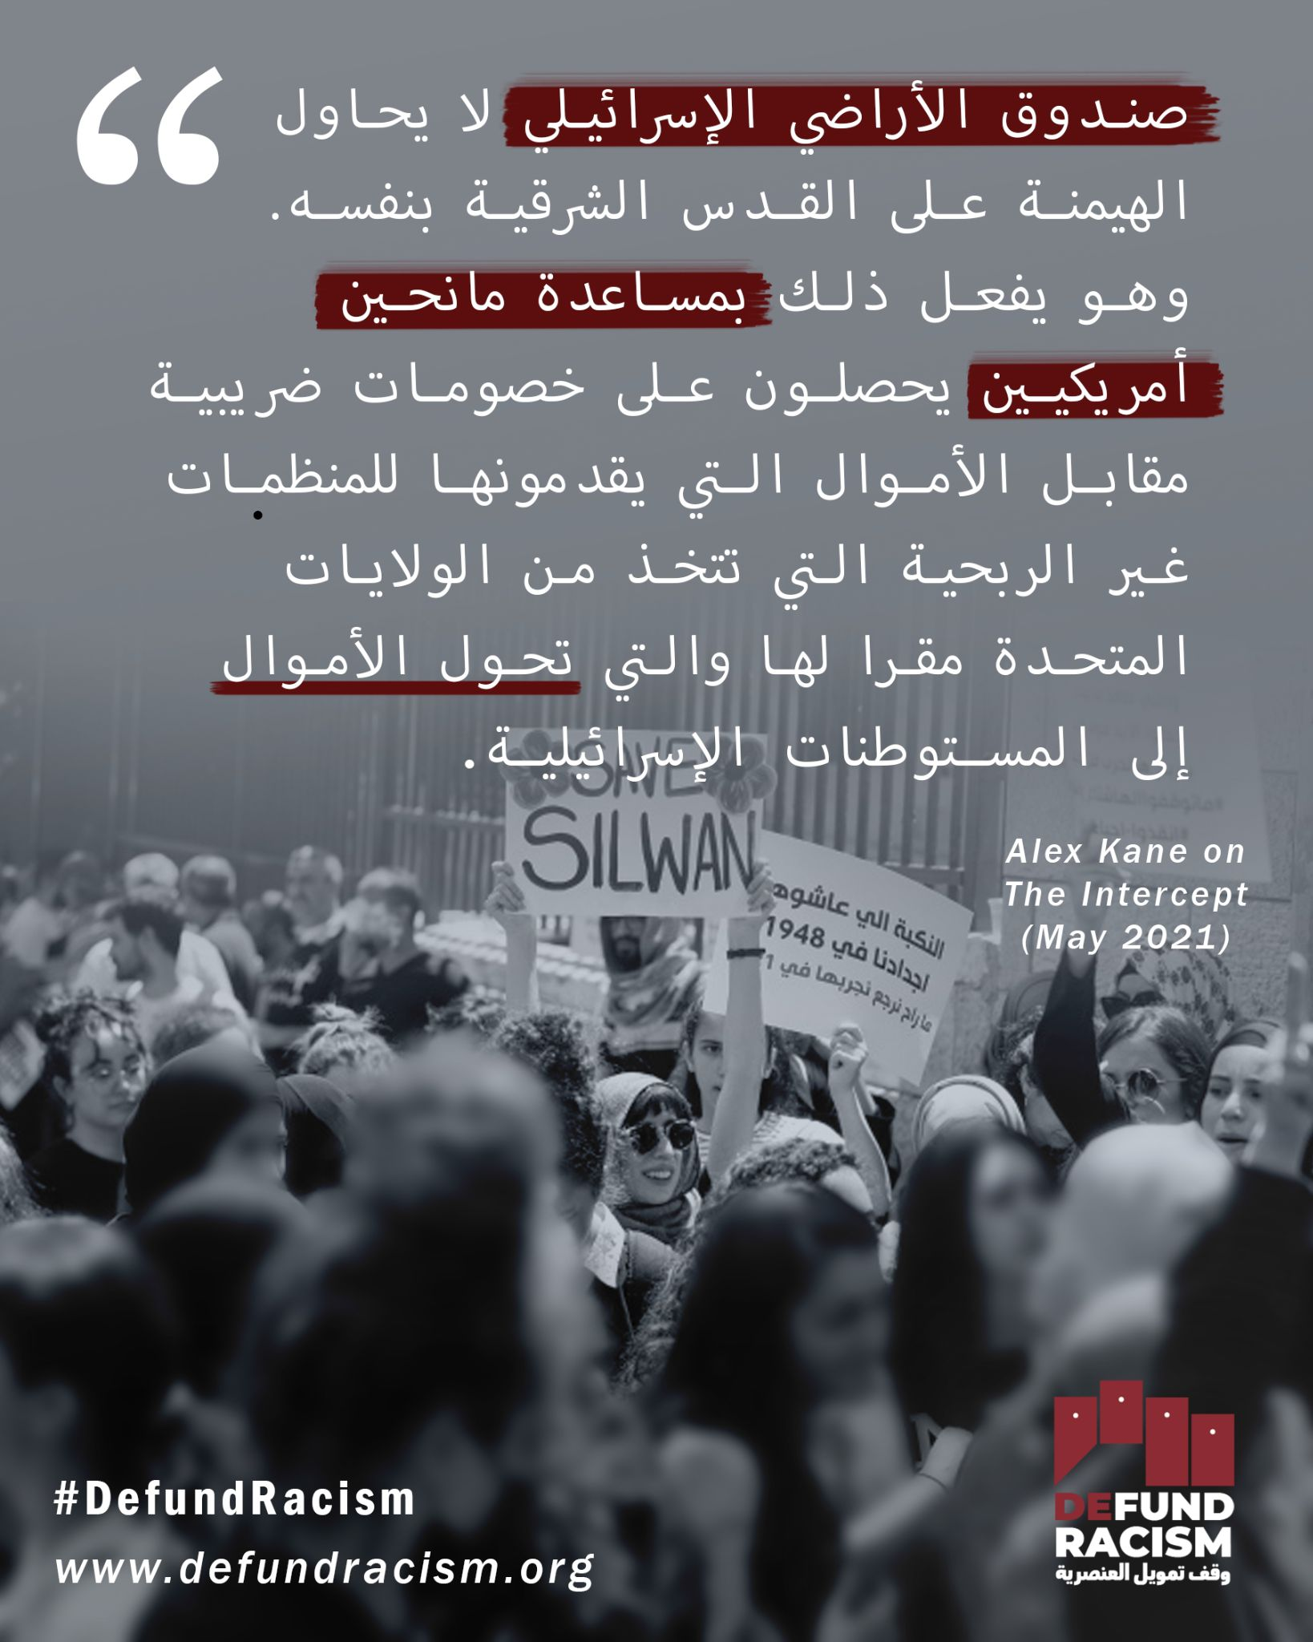
Week 6 | From the US to Palestine, racist organizations are receiving charitable money for their work. When we call to stop the funding of Israeli settler organizations, we are also calling for the defunding of racist organizations receiving charitable money in the US. The revocation of a settler organization’s charitable status could set a legal precedent - a stronger basis to target the funding of racist organizations in the US. We believe that the struggle for liberation is intersectional. This is why we call to #DefundRacism  defundracism.org | من الولايات المتحدة إلى فلسطين، تتلقى المنظمات العنصرية أموالا خيرية مقابل عملها. وعندما ندعو إلى وقف تمويل منظمات المستوطنين الإسرائيليين، فإننا ندعو أيضا إلى وقف تمويل المنظمات العنصرية التي تتلقى أموالا خيرية في الولايات المتحدة. إن إلغاء الوضع الخيري لمنظمة المستوطنين يمكن أن يشكل سابقة قانونية - أساس أقوى لاستهداف تمويل المنظمات العنصرية في الولايات المتحدة. ونعتقد أن الكفاح من أجل التحرر متعدد الجوانب. لهذا ندعو #DefundRacism  defundracism.org | From the US to Palestine, racist organizations are receiving charitable money for their work. The struggle for liberation is intersectional. Join us in a call that can work to all of our benefit. #DefundRacism defundracism.org | From the US to Palestine, racist organizations are receiving charitable money for their work. When we call to stop the funding of Israeli settler organizations, we are also calling for the defunding of racist organizations receiving charitable money in the US. The revocation of a settler organization’s charitable status could set a legal precedent - a stronger basis to target the funding of racist organizations in the US. We believe that the struggle for liberation is intersectional. This is why we call to #DefundRacism  defundracism.org | Link  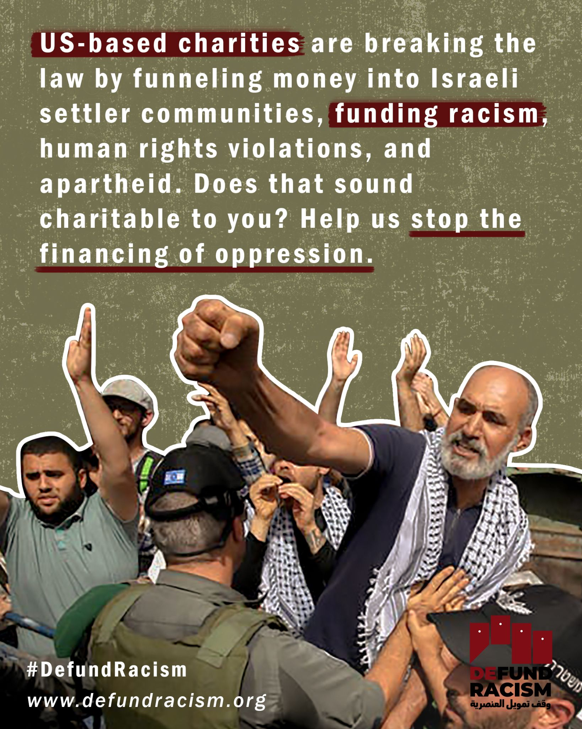 | Link  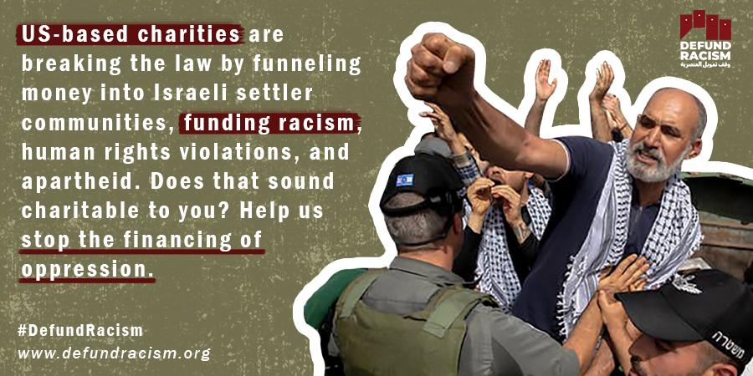 | Link  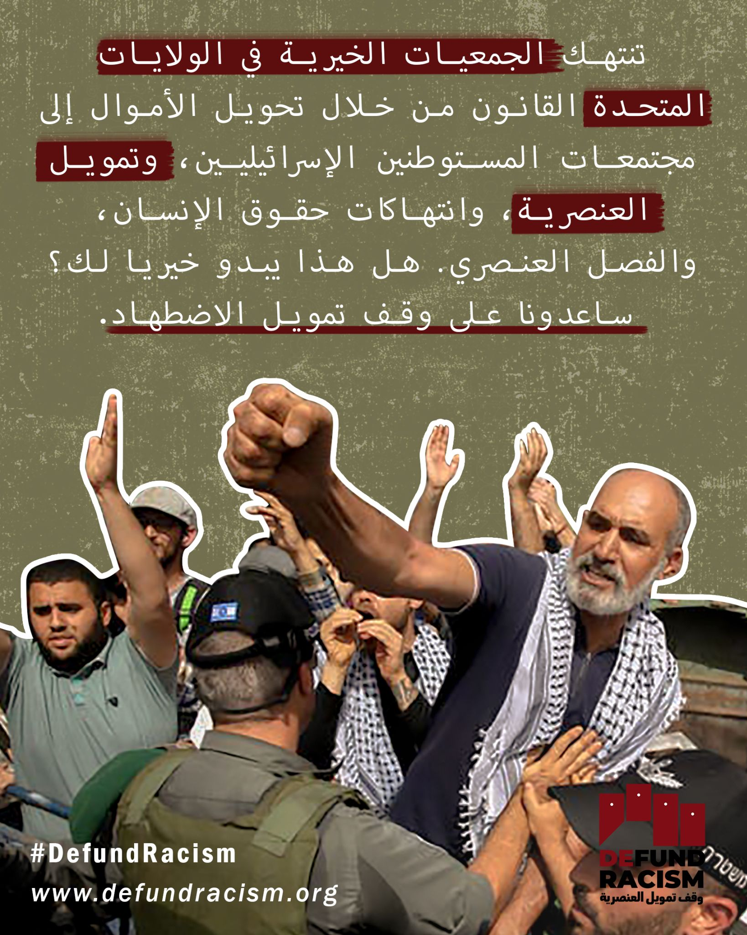
Week 6 | Every few days Israeli bulldozers demolish Palestinian homes. But often, we don’t see the settler organizations behind this violation of international law. Organizations like Regavim, Elad, Ateret Cohanim, the Hebron Fund, and the Israel Land Fund are pushing the Israeli Authorities to displace Palestinians from their homes. They are also largely funded by charitable money from the US.  To stop home demolitions and ethnic cleansing projects, we need to cut the money flowing into these organizations. Revoking their charitable status is a large and winnable step towards this direction. Are you in to #DefundRacism?  defundracism.org  Photo: Shazam Bader/AFP | تقوم الجرافات الإسرائيلية كل بضعة أيام بهدم  منازل الفلسطينيين. ولكن في كثير من الأحيان، نفشل في رؤية منظمات المستوطنين وراء هذا الانتهاك للقانون الدولي. وتدفع منظمات مثل ريغافيم، والعاد، وعطيريت كوهانيم، وصندوق الخليل، وصندوق الأراضي الإسرائيلي السلطات الإسرائيلية إلى تشريد الفلسطينيين من ديارهم. كما أنها ممولة إلى حد كبير من الأموال الخيرية من الولايات المتحدة.  ولوقف هدم المنازل ومشاريع التطهير العرقي، نحتاج إلى قطع الأموال المتدفقة إلى هذه المنظمات. وإلغاء وضعهم الخيري خطوة كبيرة يمكن كسبها نحو هذا الاتجاه. هل أنت مع #DefundRacism؟  defundracism.org | Often, during demolitions, we don’t see the settler organizations behind this violation of international law. Regavim, Elad, Ateret Cohanim, the Hebron Fund, & the Israel Land Fund are using US charitable $$ to push Israel to displace Palestinians. defundracism.org | Every few days Israeli bulldozers demolish Palestinian homes. But often, we don’t see the settler organizations behind this violation of international law. Organizations like Regavim, Elad, Ateret Cohanim, the Hebron Fund, and the Israel Land Fund are pushing the Israeli Authorities to displace Palestinians from their homes. They are also largely funded by charitable money from the US.  To stop home demolitions and ethnic cleansing projects, we need to cut the money flowing into these organizations. Revoking their charitable status is a large and winnable step towards this direction. Are you in to #DefundRacism?  defundracism.org  Photo: Shazam Bader/AFP | Link | Link | Link
Week 6 | You want to stand in solidarity with Palestinians? You can start by helping to stop Israeli settler organizations from exploiting US charitable laws in 2 steps.  Step 1: Sign the petition.  Step 2. Share the petition.  Start here:  defundracism.org  #DefundRacism | هل تريد التضامن مع الفلسطينيين؟ يمكنك البدء بالمساعدة في منع منظمات المستوطنين الإسرائيليين من استغلال القوانين الخيرية الأمريكية في خطوتين.  الخطوة الأولى: وقع على العريضة.  الخطوة الثانية-- تشارك العريضة.  ابدأ من هنا:  defundracism.org  #DefundRacism | You want to stand in solidarity with Palestinians? You can start by helping to stop Israeli settler organizations from exploiting US charitable laws in 2 steps.  Step 1: Sign the petition.  Step 2. Share the petition.  Start here:  defundracism.org  #DefundRacism | You want to stand in solidarity with Palestinians? You can start by helping to stop Israeli settler organizations from exploiting US charitable laws in 2 steps.  Step 1: Sign the petition.  Step 2. Share the petition.  Start here:  defundracism.org  #DefundRacism | For Instagram, we have a series of photos:  Graphic-6  Graphic-5  Graphic-4  Graphic-3  Graphic-2  Graphic-1 | Link | For Instagram, we have a series of photos, FB & Twitter can simply use the first one:  Graphic-6  Graphic-5  Graphic-4  Graphic-3  Graphic-2  Graphic-1
Week 7 | Elad is a Jerusalem-based settler organization which works on the colonization of East Jerusalem. In its acquisition of land in Silwan, it relies on legal tactics and the pretext of archeological excavation in the so-called “City of David.”  It receives charitable donations through their New York based fundraiser American Friends of Ir David. We do not believe that settler-colonialism is charitable work. If you think so too, sign and share this petition and get engaged to #DefundRacism  defundracism.org | منظمة "العاد" هي منظمة استيطانية مقرها القدس وتعمل على استعمار القدس الشرقية. في استحواذها على الأراضي في سلوان، تعتمد على التكتيكات القانونية وذريعة التنقيب الأثري في ما تتلق عليه "مدينة داود".  وهي تتلقى التبرعات الخيرية من خلال جمع التبرعات التي تتخذ من نيويورك مقرا لها، وهي جمعية أصدقاء ديفيد الأمريكية. ولا نعتقد أن الاستعمار الاستيطاني عمل خيري. إذا كنت تعتقد ذلك أيضا، وقع وشارك هذه العريضة وانخرط في #DefundRacism  defundracism.org | Elad is a settler org which works on the colonization of East Jerusalem. Its land grabs in Silwan rely on legal tactics & the pretext of archeological excavation in the so-called “City of David.” It is funded by US charitable $$$.  Ready to speak out? defundracism.org | Elad is a Jerusalem-based settler organization which works on the colonization of East Jerusalem. In its acquisition of land in Silwan, it relies on legal tactics and the pretext of archeological excavation in the so-called “City of David.”  It receives charitable donations through their New York based fundraiser American Friends of Ir David. We do not believe that settler-colonialism is charitable work. If you think so too, sign and share this petition and get engaged to #DefundRacism  defundracism.org | Link  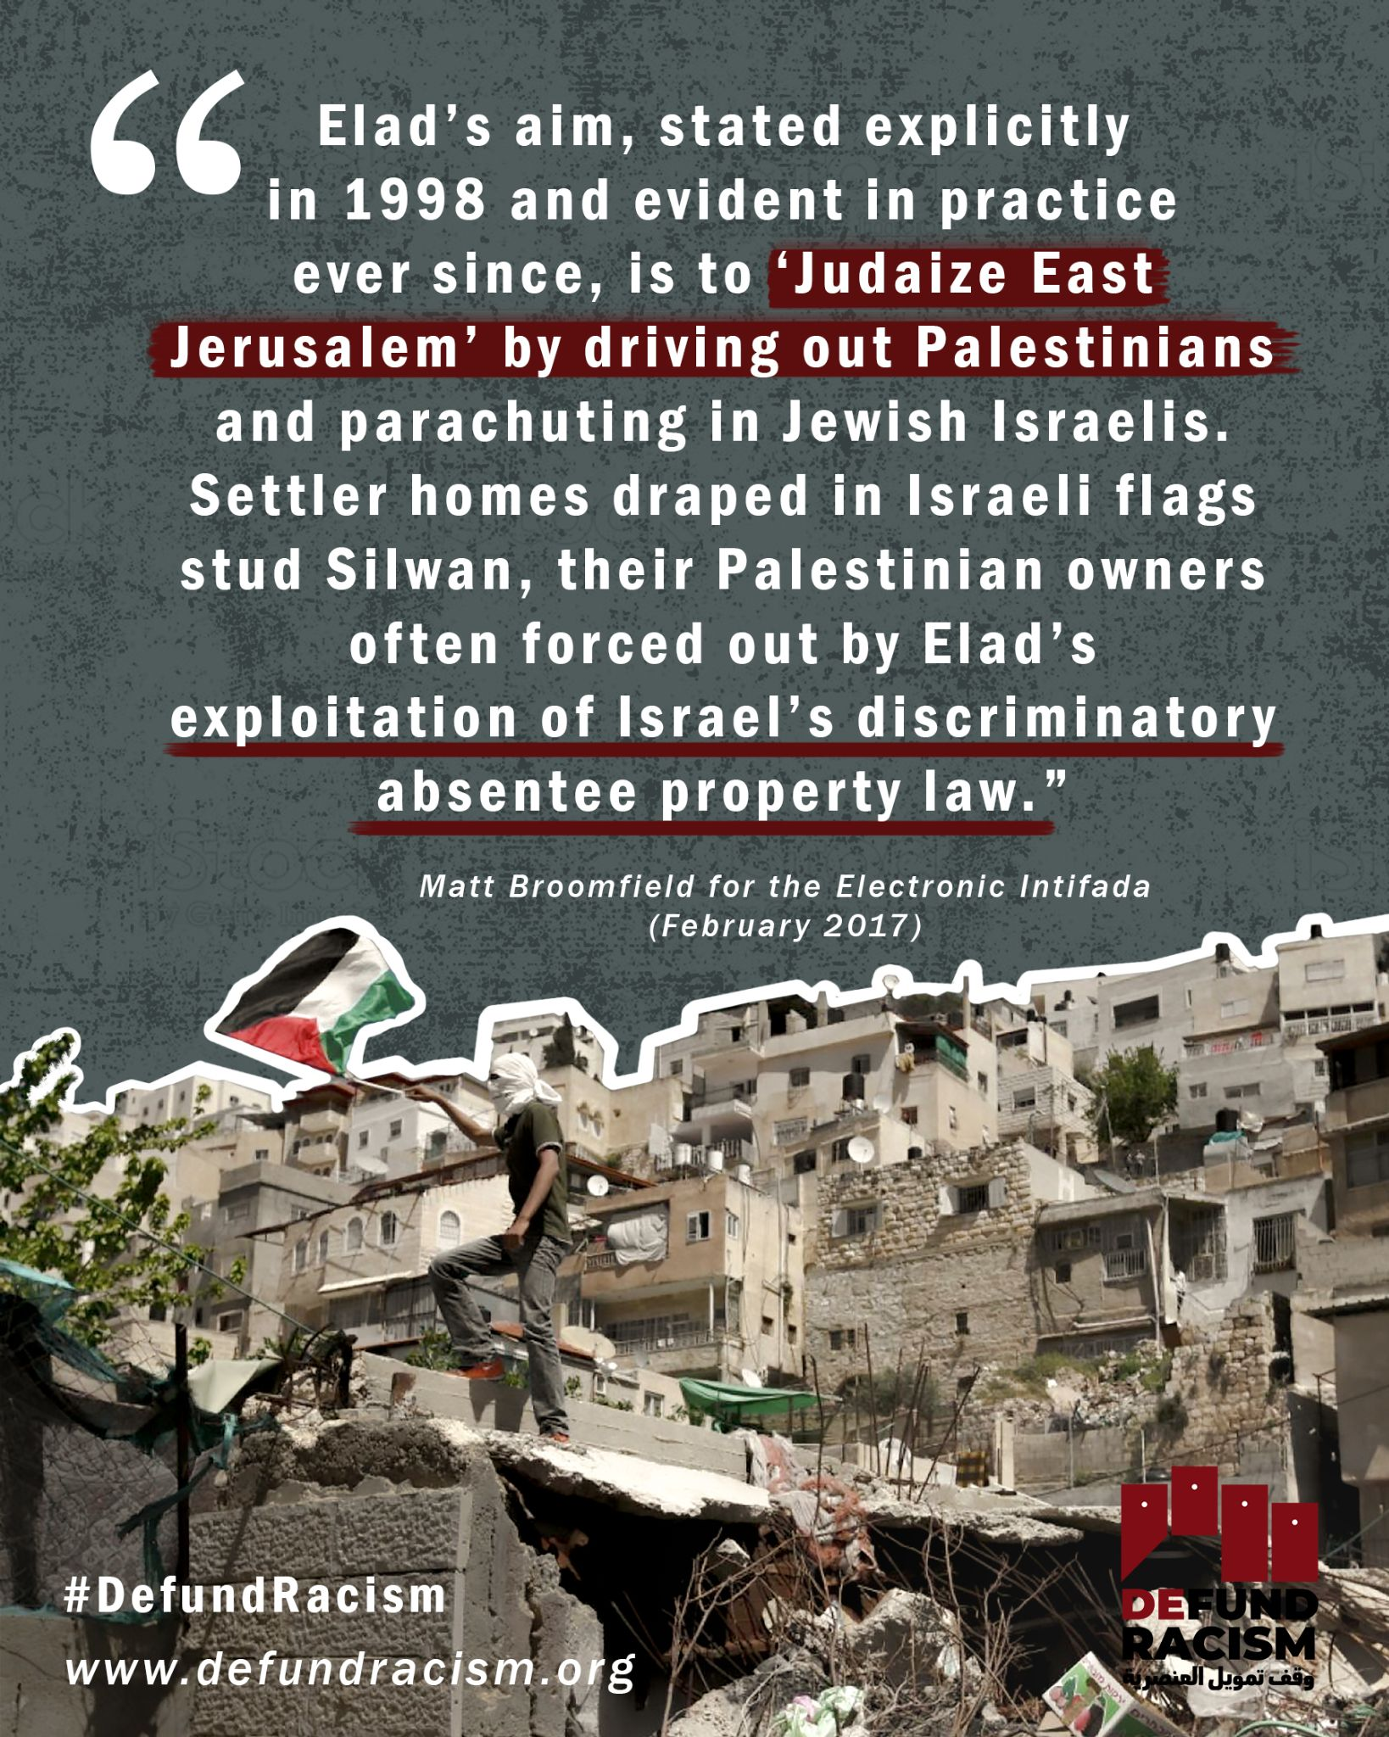 | Link  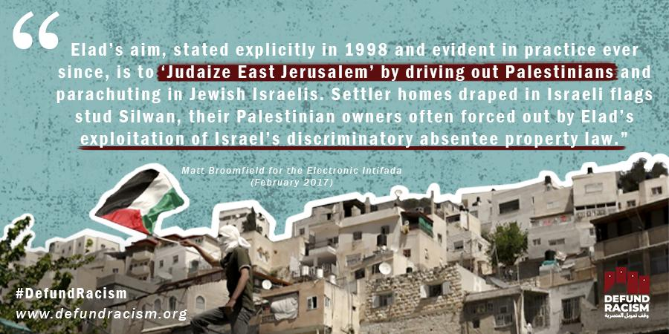 | Link  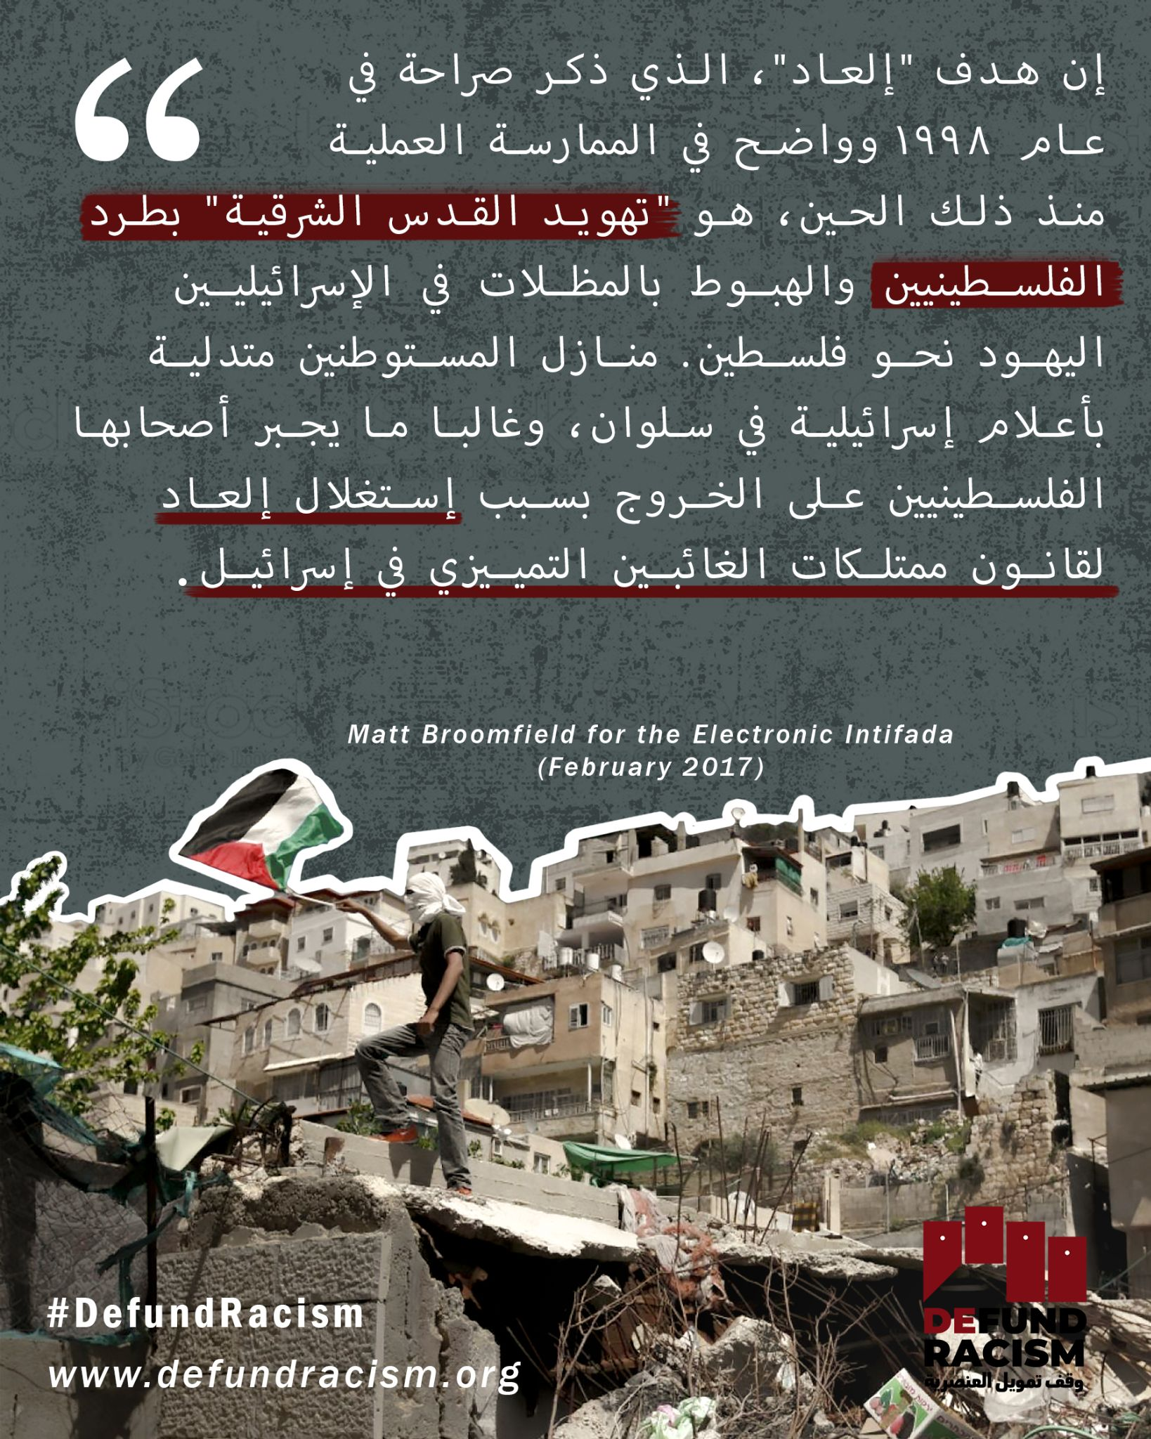
Week 7 | Solidarity must include targeting the funding of oppression. Every year, millions of dollars of charitable donations are funneled from the US into the Israeli settler movement. Palestinians are calling on the people in New York State to stop the funding of racist settler organizations through US tax money.  Take action:  defundracism.org  #DefundRacism  Photo: Christian Peacemaker Teams Palestine | ويجب أن يشمل التضامن استهداف تمويل القمع. وفي كل عام، يتم تحويل ملايين الدولارات من التبرعات الخيرية من الولايات المتحدة إلى حركة المستوطنين الإسرائيليين. يطالب الفلسطينيون الشعب فى ولاية نيويورك بوقف تمويل المنظمات الاستيطانية العنصرية من خلال اموال الضرائب الامريكية .  اتخاذ الإجراءات اللازمة:  defundracism.org  #DefundRacism | Every year, millions of $$ of charitable donations are funneled from the US into the Israeli settler movement. Palestinians are calling on allies in New York to stop the funding of these racist settler organizations. defundracism.org #DefundRacism | Solidarity must include targeting the funding of oppression. Every year, millions of dollars of charitable donations are funneled from the US into the Israeli settler movement. Palestinians are calling on the people in New York State to stop the funding of racist settler organizations through US tax money.  Take action:  defundracism.org  #DefundRacism  Photo: Christian Peacemaker Teams Palestine | Link | Link | Link
Week 7 | Organizations with the 501(c)(3) charity tax status must ensure that the projects they spend their money on align with domestic and international law. The Internal Revenue Service (IRS) defines “charitable works” as “lessening neighborhood tensions; eliminating prejudice and discrimination; defending human and civil rights secured by law.”  Israeli settler organizations clearly work for a very different goal. They privilege Jewish Israelis and dispossess Palestinians in order to build up their vision of a land free of indigenous Palestinians. They encourage discrimination, violence and work against international law.  It’s time to revoke their status and #DefundRacism  Take action:  defundracism.org | يجب على المنظمات التي تتمتع بوضع ضريبي خيري أن تضمن أن المشاريع التي تنفق أموالها عليها تتماشى مع القانون المحلي والدولي. وتعرف دائرة الإيرادات الداخلية "الأعمال الخيرية" بأنها "تخفيف التوترات في الأحياء؛ القضاء على التحيز والتمييز؛ الدفاع عن حقوق الإنسان والحقوق المدنية التي يكفلها القانون".  ومن الواضح أن منظمات المستوطنين الإسرائيليين تعمل من أجل تحقيق هدف مختلف تماما. فهي تمنح امتيازات لليهود الإسرائيليين وتسلب الفلسطينيين من ممتلكاتهم من أجل بناء رؤيتهم لأرض خالية من الفلسطينيين الأصليين. وهي تشجع التمييز والعنف وتعمل ضد القانون الدولي.  لقد حان الوقت لإلغاء وضعهم #DefundRacism  اتخاذ الإجراءات اللازمة:  defundracism.org | Israeli settler organizations do not meet the definition of "charitable" under US tax law. They privilege Jewish Israelis & dispossess Palestinians as part of their vision of a land free of indigenous Palestinians.  It’s time to revoke their status. defundracism.org | Organizations with the 501(c)(3) charity tax status must ensure that the projects they spend their money on align with domestic and international law. The Internal Revenue Service (IRS) defines “charitable works” as “lessening neighborhood tensions; eliminating prejudice and discrimination; defending human and civil rights secured by law.”  Israeli settler organizations clearly work for a very different goal. They privilege Jewish Israelis and dispossess Palestinians in order to build up their vision of a land free of indigenous Palestinians. They encourage discrimination, violence and work against international law.  It’s time to revoke their status and #DefundRacism  Take action:  defundracism.org | Link | Link | Link
Week 8 | Ateret Cohanim is a Jerusalem-based settler organization which works to replace Palestinian residents in Sheikh Jarrah and other neighborhoods with Jewish settlers. Its goal is to create a Jewish demographic majority in Jerusalem - which means evicting Palestinians from the Old City and East Jerusalem.  Its work is funded by the New York-based fundraiser American Friends of Ateret Cohanim. In this way, “charitable” money from the US is funneled into the mechanisms of dispossessing Palestinians.  We believe that this is not a charity, and that we need to revoke their charitable status. Join us in calling to #DefundRacism  defundracism.org  Photo: Oren Ziv/ActiveStills | عطيريت كوهانيم هي منظمة استيطانية مقرها القدس تعمل على استبدال السكان الفلسطينيين في الشيخ جراح وأحياء أخرى بالمستوطنين اليهود. وهدفها هو خلق أغلبية ديموغرافية يهودية في القدس - وهو ما يعني طرد الفلسطينيين من البلدة القديمة والقدس الشرقية.  ويتم تمويل عملها من قبل جمعية أصدقاء عطيريت كوهانيم الأمريكية لجمع التبرعات ومقرها نيويورك. وبهذه الطريقة، يتم تحويل الأموال "الخيرية" من الولايات المتحدة إلى آليات تجريد الفلسطينيين من الملكية.  ونحن نعتقد أن هذه ليست أعمال جمعية خيرية، وأننا بحاجة إلى إلغاء وضعهم الخيري. انضم إلينا في الاتصال #DefundRacism  defundracism.org | Ateret Cohanim is a settler organization which works to replace Palestinians in Sheikh Jarrah with Jewish settlers. Its goal is to create a Jewish demographic majority in Jerusalem, which means evicting Palestinians from the Old City & East Jerusalem. defundracism.org | Ateret Cohanim is a Jerusalem-based settler organization which works to replace Palestinian residents in Sheikh Jarrah and other neighborhoods with Jewish settlers. Its goal is to create a Jewish demographic majority in Jerusalem - which means evicting Palestinians from the Old City and East Jerusalem.  Its work is funded by the New York-based fundraiser American Friends of Ateret Cohanim. In this way, “charitable” money from the US is funneled into the mechanisms of dispossessing Palestinians.  We believe that this is not a charity, and that we need to revoke their charitable status. Join us in calling to #DefundRacism  defundracism.org  Photo: Oren Ziv/ActiveStills | Link  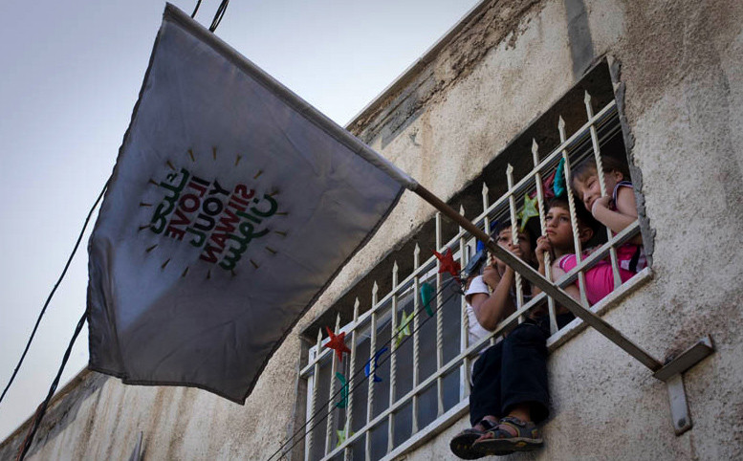 | Link | Link
Week 8 | Palestinians are calling on our allies in the US to stop the funding of Israeli settler organizations through charitable donations. This is a simple and winnable change, which can result in meaningful changes on the ground not only in Palestine but also across the US. Let’s #DefundRacism, here and there.  defundracism.org | يدعو الفلسطينيون حلفائهم في الولايات المتحدة إلى وقف تمويل منظمات المستوطنين الإسرائيليين من خلال التبرعات الخيرية. وهذا تغيير بسيط ويمكن كسبه، ويمكن أن يؤدي إلى تغييرات قيمة على أرض الواقع ليس فقط في فلسطين ولكن أيضا في جميع أنحاء الولايات المتحدة.  دعونا #DefundRacism، هنا وهناك.  defundracism.org | Palestinians are calling on allies in the US to stop the funding of Israeli settler organizations through charitable donations. This is a simple & winnable change, which can result in changes on the ground not only in Palestine but also across the US. defundracism.org | Palestinians are calling on our allies in the US to stop the funding of Israeli settler organizations through charitable donations. This is a simple and winnable change, which can result in meaningful changes on the ground not only in Palestine but also across the US. Let’s #DefundRacism, here and there.  defundracism.org | Link  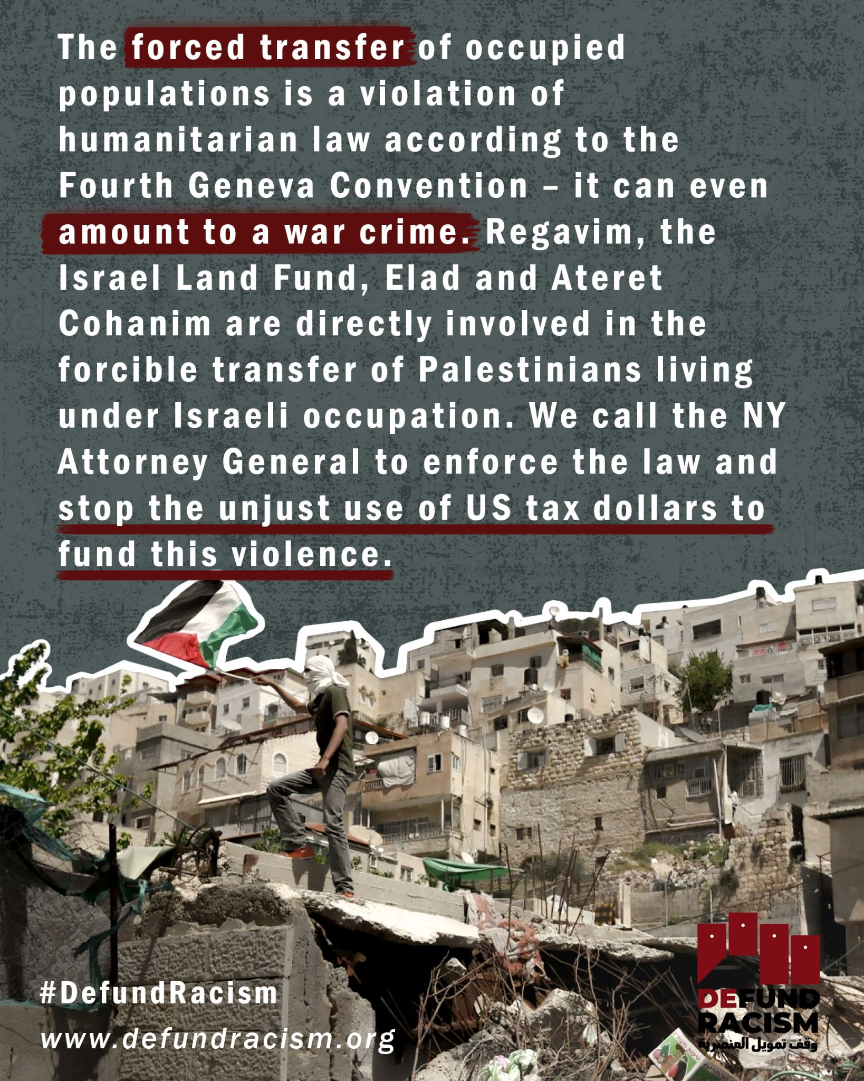 | Link  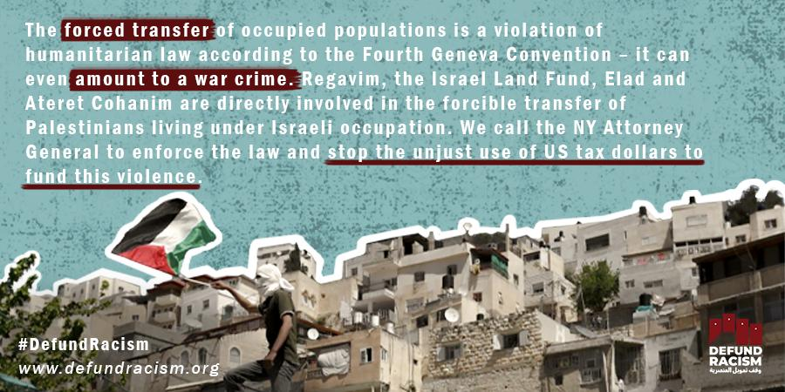 | Link  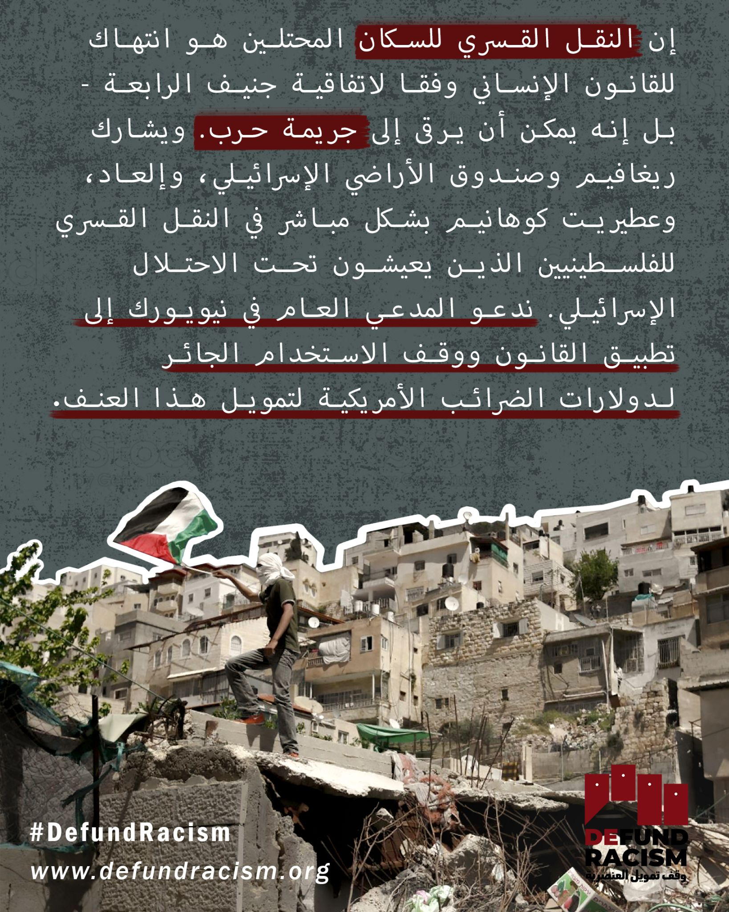
Week 8 | From the ethnic cleansing of Sheikh Jarrah and Silwan to the demolition of homes in the Naqab, Golan Heights, and West Bank: the violence of forced displacement is funded by US charitable money. Settler organizations such as Regavim and Elad receive millions of dollars every year, and much of it goes toward racist ends.  With one decision by one person - New York State Attorney General Leticia James - this movement of “charitable” money could be stopped. Take action and #DefundRacism:  defundracism.org  Photo: Christian Peacemaker Teams Palestine | من التطهير العرقي للشيخ جراح وسلوان إلى هدم المنازل في النقب ومرتفعات الجولان والضفة الغربية: يتم تمويل العنف الناجم عن النزوح القسري بأموال خيرية أمريكية. وتتلقى منظمات المستوطنين مثل ريغافيم وإلعاد ملايين الدولارات كل عام، ويذهب الكثير منها إلى غايات ومشاريع عنصرية.  مع قرار واحد من قبل شخص واحد -- ولاية نيويورك المدعي العام ليتيسيا جيمس -- يمكن وقف هذه الحركة من الأموال "الخيرية"  . #DefundRacism:  defundracism.org | From evictions in Sheikh Jarrah & Silwan to the demolition of homes in the Naqab, Golan Heights, & West Bank: Palestinians' forced displacement is funded by US charitable $$. NY AG Tish James can help stop a big portion of that money with one decision. defundracism.org | From the ethnic cleansing of Sheikh Jarrah and Silwan to the demolition of homes in the Naqab, Golan Heights, and West Bank: the violence of forced displacement is funded by US charitable money. Settler organizations such as Regavim and Elad receive millions of dollars every year, and much of it goes toward racist ends.  With one decision by one person - New York State Attorney General Leticia James - this movement of “charitable” money could be stopped. Take action and #DefundRacism:  defundracism.org  Photo: Christian Peacemaker Teams Palestine | Link | Link | Link
Week 9 | You don’t need to be in Palestine to stand for justice here. Every year, millions of dollars of tax-deductible money flows into the Israeli settler movement, funding propaganda and the creation of ‘facts on the ground’ that exclude Palestinians from their historical lands.  We can stop this flow of money, but we can’t do it without you.  Join the movement:  defundracism.org  #DefundRacism | لا تحتاج إلى أن تكون في فلسطين لتدافع عن العدالة هنا. وفي كل عام، تتدفق ملايين الدولارات من الأموال المعفاة من الضرائب إلى حركة المستوطنين الإسرائيليين، وتمول الدعاية وتخلق "حقائق على الأرض" تستبعد الفلسطينيين من أراضيهم التاريخية.  يمكننا إيقاف تدفق المال هذا، ولكن لا يمكننا أن نفعل ذلك بدونك.  انضم إلى الحركة:  defundracism.org  #DefundRacism | You don’t need to be in Palestine to stand for justice here. Every year, millions of tax-deductible dollars flow into the Israeli settler movement, funding propaganda & the creation of ‘facts on the ground’ that exclude Palestinians from their historical lands. #DefundRacism | You don’t need to be in Palestine to stand for justice here. Every year, millions of dollars of tax-deductible money flows into the Israeli settler movement, funding propaganda and the creation of ‘facts on the ground’ that exclude Palestinians from their historical lands.  We can stop this flow of money, but we can’t do it without you.  Join the movement:  defundracism.org  #DefundRacism | Link | Link | Link
Week 9 | How can it be Regavim, an organization which has called for the complete erasure of the impoverished Palestinian village of Khan al-Ahmar, is a recipient of charitable donations from the US?  We must end the funding of Regavim - as well as groups like it - under the pretext of charitable works. #DefundRacism  defundracism.org  Photo: Getty Images | كيف يمكن أن تكون منظمة "ريغافيم"، التي دعت إلى محو قرية خان الأحمر الفلسطينية الفقيرة بالكامل، متلقية للتبرعات الخيرية من الولايات المتحدة؟  يجب أن ننهي تمويل ريغافيم - وكذلك جماعات مثلها - بحجة الأعمال الخيرية. #DefundRacism  defundracism.org | How can it be Regavim, which has called for the complete erasure of the Palestinian village of Khan al-Ahmar, is a recipient of charitable money?  We must end the funding of Regavim - as well as groups like it - under the pretext of charitable works. defundracism.org | How can it be Regavim, an organization which has called for the complete erasure of the impoverished Palestinian village of Khan al-Ahmar, is a recipient of charitable donations from the US?  We must end the funding of Regavim - as well as groups like it - under the pretext of charitable works. #DefundRacism  defundracism.org  Photo: Getty Images | Link  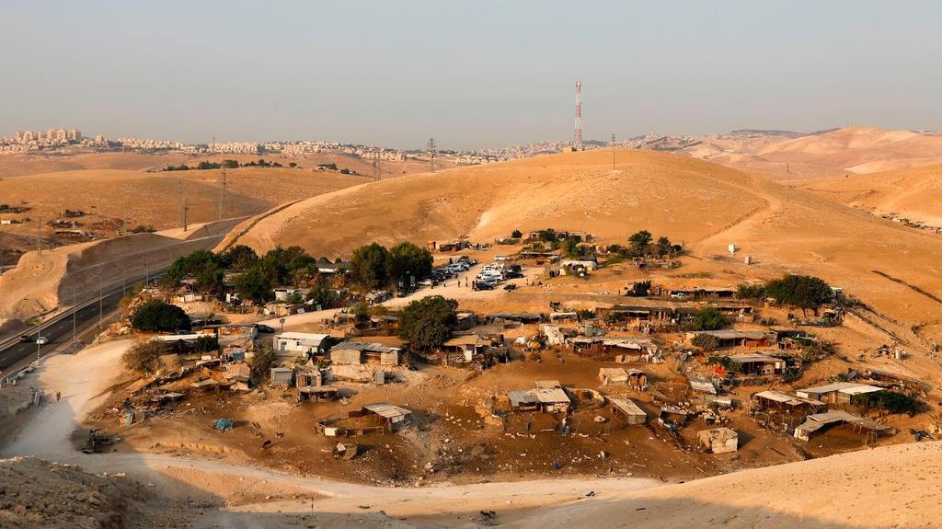 | Link | Link
Week 9 | Non-governmental organizations like the Hebron Fund, Regavim, and Elad have historically served as key contributors in settler-colonial regimes. Before the establishment of the State of Israel, the Zionist movement - composed of numerous organizations and groups - funded and instituted a program of settler-colonialism. This program carries on today, and with it, the elimination and erasure of indigenous Palestinian communities. Supported by charitable money from the US, settler organizations work for the dispossession of Palestinians and takeover of their land.  This never was and never will be charitable work. We’re calling to #DefundRacism and end the support of violence through US tax dollars.  Join our call:  defundracism.org | قد عملت المنظمات غير الحكومية مثل صندوق الخليل، وريغافيم، والعاد تاريخيا كمساهمين رئيسيين في الأنظمة الاستعمارية الاستيطانية. قبل تأسيس دولة إسرائيل، قامت الحركة الصهيونية - المؤلفة من العديد من المنظمات والجماعات - بتمويل ووضع برنامج للاستعمار الاستيطاني. يستمر هذا البرنامج اليوم، ومعه، القضاء على المجتمعات الفلسطينية الأصلية ومحوها. وبدعم من الأموال الخيرية من الولايات المتحدة، تعمل منظمات المستوطنين من أجل تجريد الفلسطينيين من ممتلكاتهم والاستيلاء على أراضيهم.  هذا لم يكن ولن يكون عملا خيريا أبدا نحن ندعو إلى #DefundRacism وإنهاء دعم العنف من خلال دولارات الضرائب الأمريكية.  انضم إلى دعوتنا:  defundracism.org | Before the establishment of Israel, the Zionist movement funded a program of colonization. This program carries on today - through organizations supported by tax-deductible donations from the US - and with it, the elimination of indigenous communities. defundracism.org | Non-governmental organizations like the Hebron Fund, Regavim, and Elad have historically served as key contributors in settler-colonial regimes. Before the establishment of the State of Israel, the Zionist movement - composed of numerous organizations and groups - funded and instituted a program of settler-colonialism. This program carries on today, and with it, the elimination and erasure of indigenous Palestinian communities. Supported by charitable money from the US, settler organizations work for the dispossession of Palestinians and takeover of their land.  This never was and never will be charitable work. We’re calling to #DefundRacism and end the support of violence through US tax dollars.  Join our call:  defundracism.org | Link  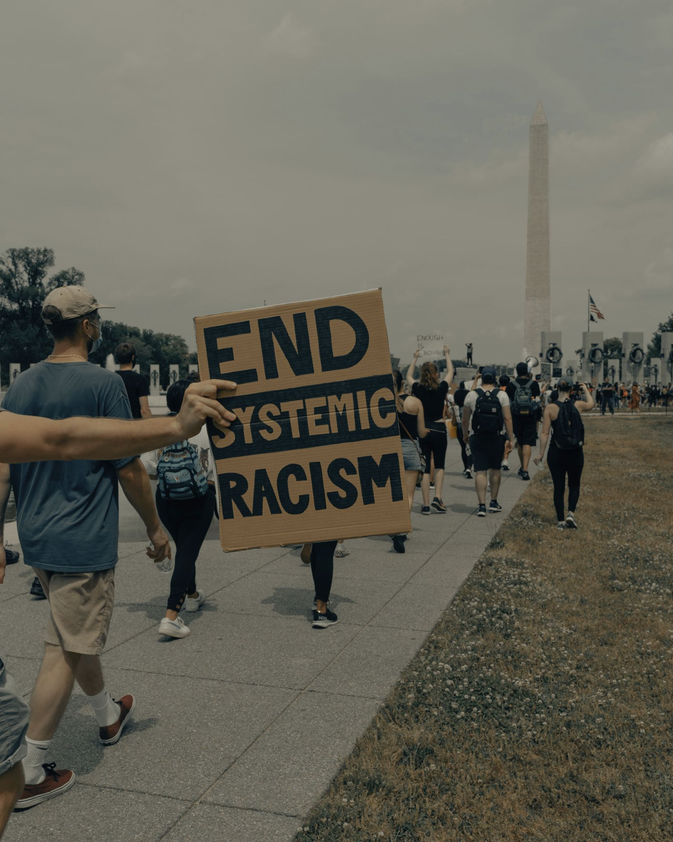 | Link | Link
Week 10 | The daily acts of violence in Hebron result largely from Israeli settlers and the greater squatter movement operating with impunity. They are part of the ongoing Israeli settler-colonial project, supported by US-based “charities” like the Hebron Fund. We can revoke their charitable status together - ending their funding and creating a useful precedent for defunding other hate groups benefiting from charitable status.  defundracism.org  #DefundRacism | تنجم أعمال العنف اليومية في الخليل إلى حد كبير عن المستوطنين الإسرائيليين وعن حركة “المستقطنين” التي تعمل دون عقاب. وهي جزء من المشروع الإسرائيلي الاستعماري الاستيطاني الجاري، بدعم من "جمعيات خيرية" مقرها الولايات المتحدة مثل صندوق الخليل. يمكننا إلغاء وضعهم الخيري معا - إنهاء تمويلهم وخلق سابقة قانونية مفيدة لإلغاء تمويل جماعات الكراهية والعنصرية الأخرى المستفيدة من الوضع الخيري.  defundracism.org  #DefundRacism | The daily violence in Hebron results largely from Israeli settlers operating with impunity. They are part of the ongoing Israeli settler-colonial project, supported by US-based “charities” like the Hebron Fund. Let's halt their funding. defundracism.org  #DefundRacism | The daily acts of violence in Hebron result largely from Israeli settlers and the greater squatter movement operating with impunity. They are part of the ongoing Israeli settler-colonial project, supported by US-based “charities” like the Hebron Fund. We can revoke their charitable status together - ending their funding and creating a useful precedent for defunding other hate groups benefiting from charitable status.  defundracism.org  #DefundRacism | Link  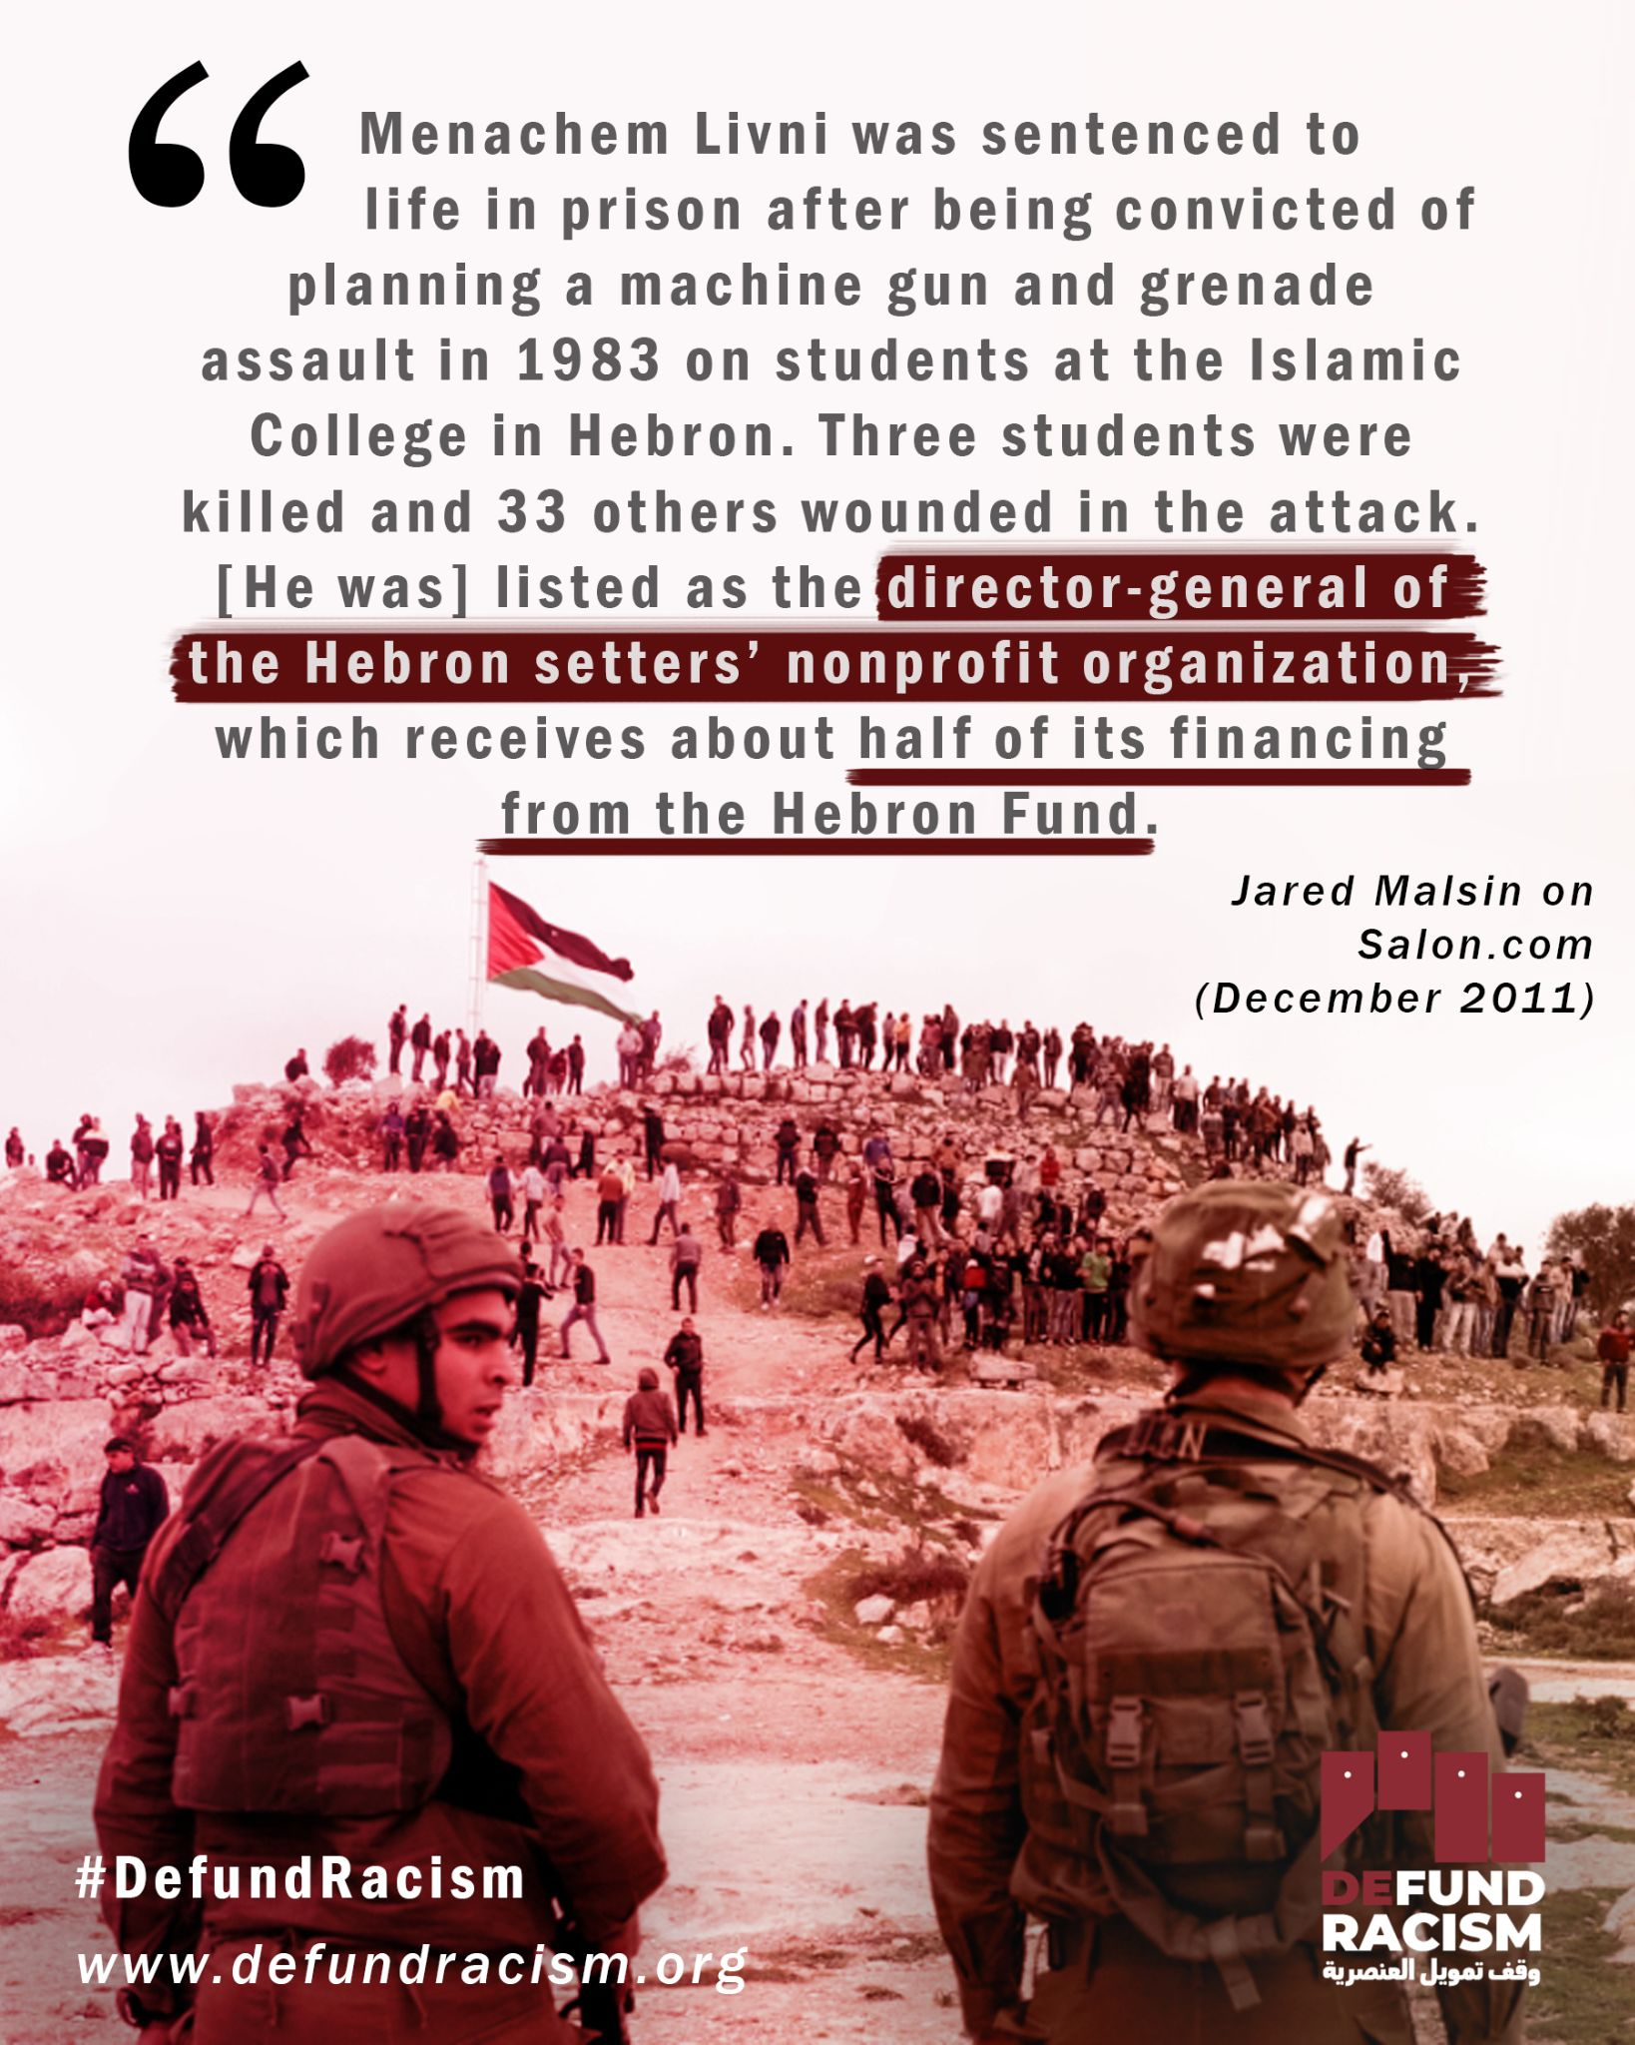 | Link  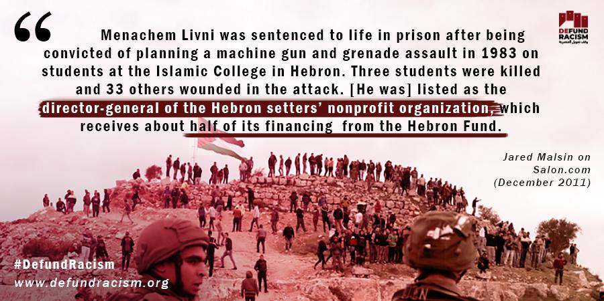 | Link  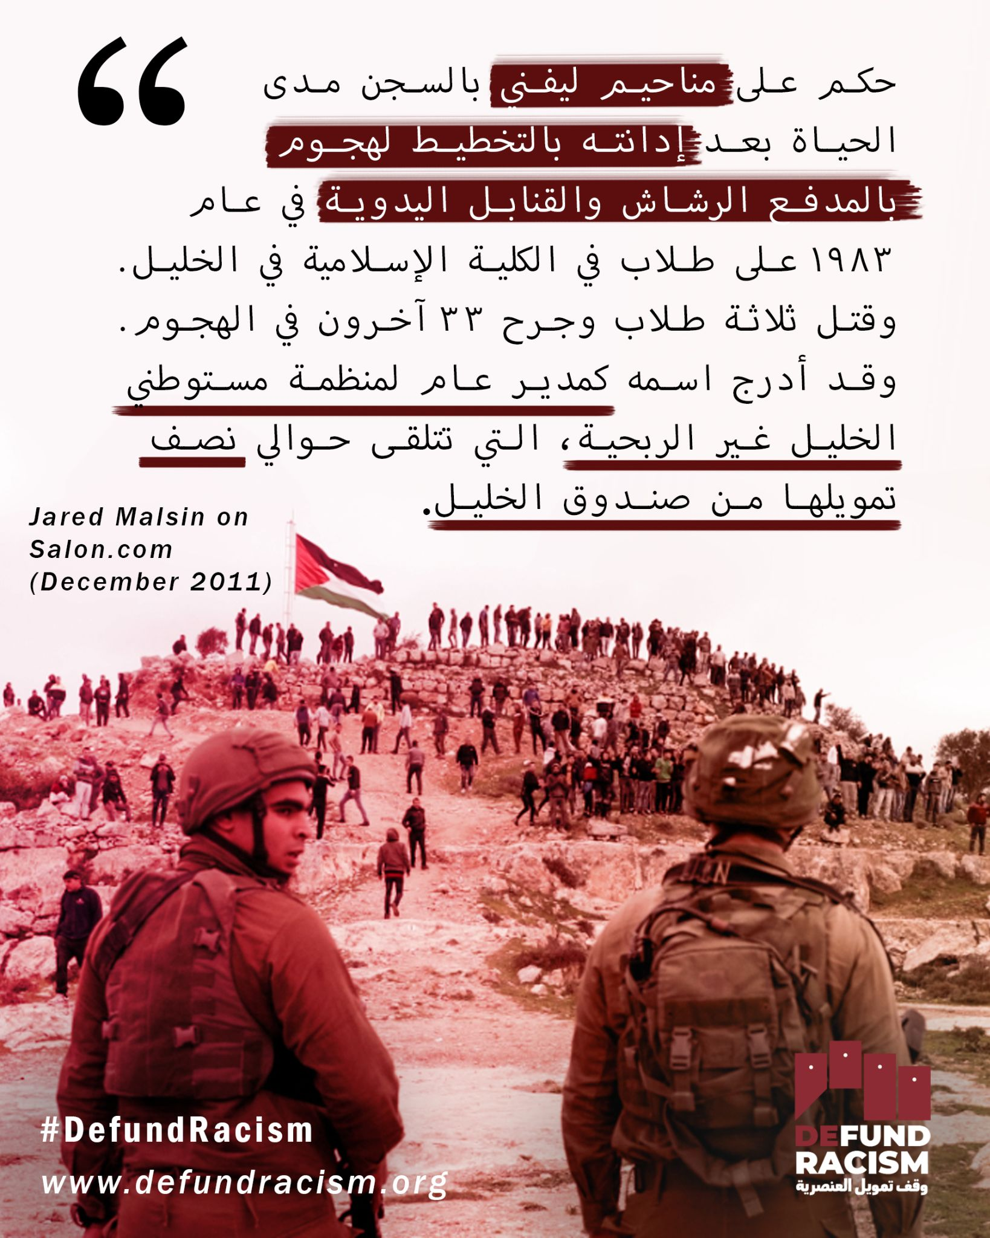
Week 10 | The Israel Land Fund is not a charity. Its work is directed against Palestinian existence in Jerusalem. Its founder and also the current Deputy Mayor of Jerusalem, Arieh King, yelled at a Palestinian activist in Sheikh Jarrah that “it’s a pity [the bullet] didn’t go in here,” while pointing to his own forehead.  How can it be that an organization with these principles and directors can receive charitable money through the US? Are you down to defund racists? defundracism.org  #DefundRacism | صندوق الأراضي الإسرائيلية ليس مؤسسة خيرية. إن عملها موجه ضد الوجود الفلسطيني في القدس. وصرخ مؤسسها ونائب عمدة القدس الحالي، أريه كينغ، على ناشط فلسطيني في الشيخ جراح قائلا: "من المؤسف أن [الرصاصة] لم تدخل إلى هنا"، بينما كان يشير إلى جبهته.  كيف يمكن لمنظمة بهذه المبادئ الحصول على أموال خيرية من خلال الولايات المتحدة؟ هل أنت مع العمل على إلغاء تمويل العنصريين؟ defundracism.org  #DefundRacism | The founder of the Israel Land Fund & current Deputy Mayor of Jerusalem, Arieh King, told a Palestinian shooting victim & activist that “it’s a pity [the bullet] didn’t go in here,” while pointing to his own forehead.  We're always down to defund racists. defundracism.org | The Israel Land Fund is not a charity. Its work is directed against Palestinian existence in Jerusalem. Its founder and also the current Deputy Mayor of Jerusalem, Arieh King, yelled at a Palestinian activist in Sheikh Jarrah that “it’s a pity [the bullet] didn’t go in here,” while pointing to his own forehead.  How can it be that an organization with these principles and directors can receive charitable money through the US? Are you down to defund racists? defundracism.org  #DefundRacism | Link  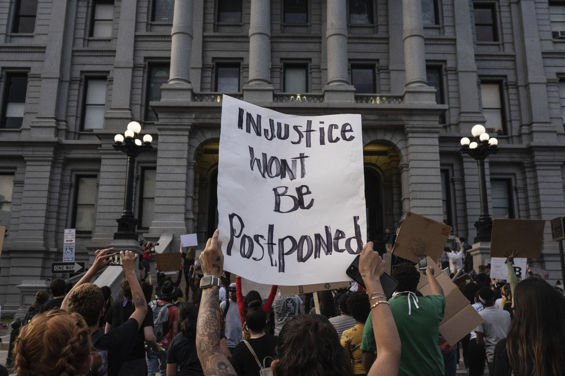 | Link | Link
Week 10 | Settler-colonialism is not charitable work. But despite this obvious fact, millions of dollars are funneled into Israeli settler organizations under the guise of charity. Through a 501(c)(3) tax status, groups like Regavim, Ateret Cohanim or Elad receive tax exempt donations. This money is used to push forth a policy of dispossessing Palestinians from their homes and supporting the growth of settlements. This is wrong and must be changed. Take action and join us in the call to #DefundRacism  defundracism.org | إن الاستعمار الاستيطاني ليس عملا خيريا. ولكن على الرغم من هذه الحقيقة الواضحة، يتم تحويل ملايين الدولارات إلى منظمات المستوطنين الإسرائيليين تحت ستار الأعمال الخيرية. من خلال 501 (ج)(3) حالة ضريبية، مجموعات مثل ريغافيم، عطيريت كوهانيم أو العاد تلقي التبرعات معفاة من الضرائب. وتستخدم هذه الأموال لدفع سياسة تجريد الفلسطينيين من ديارهم ودعم نمو المستوطنات. هذا اجرام ويجب تغييره. اتخذ إجراءات الانضمام إلينا في الدعوة إلى #DefundRacism  defundracism.org | Settler-colonialism is not charitable work. Despite this obvious fact, millions of $$ are funneled into Israeli settler orgs under the guise of charity. That means groups like Regavim, Ateret Cohanim & Elad receive tax-exempt donations. We can change this. defundracism.org | Settler-colonialism is not charitable work. But despite this obvious fact, millions of dollars are funneled into Israeli settler organizations under the guise of charity. Through a 501(c)(3) tax status, groups like Regavim, Ateret Cohanim or Elad receive tax exempt donations. This money is used to push forth a policy of dispossessing Palestinians from their homes and supporting the growth of settlements. This is wrong and must be changed. Take action and join us in the call to #DefundRacism  defundracism.org | Link | Link | Link

